Module 2

ASia pacific College

User Manual

SM Foundation Tracking System

August 28, 2015

# System Configurations

# Operations

* Front-end
  + 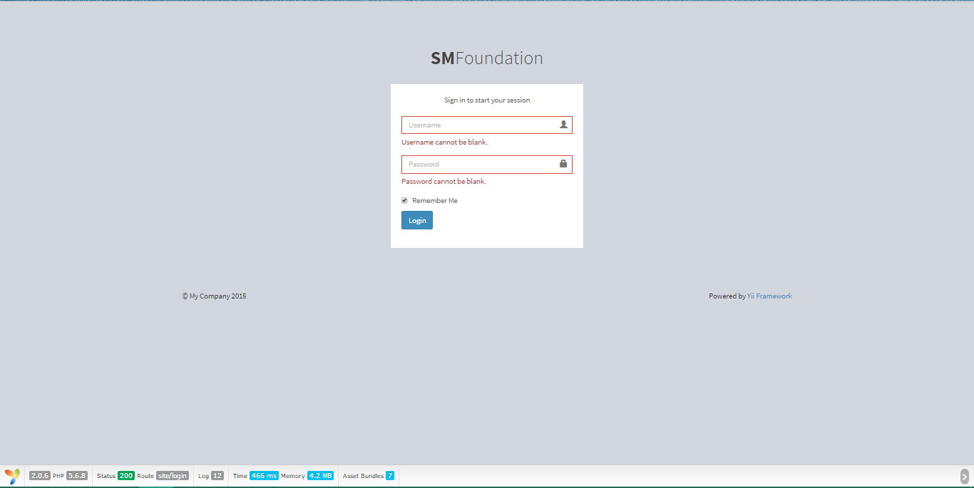Login

1. Enter username and password (credentials)
2. Optional: tick remember me for autofill next login
3. press login
   * view profile (scholar)

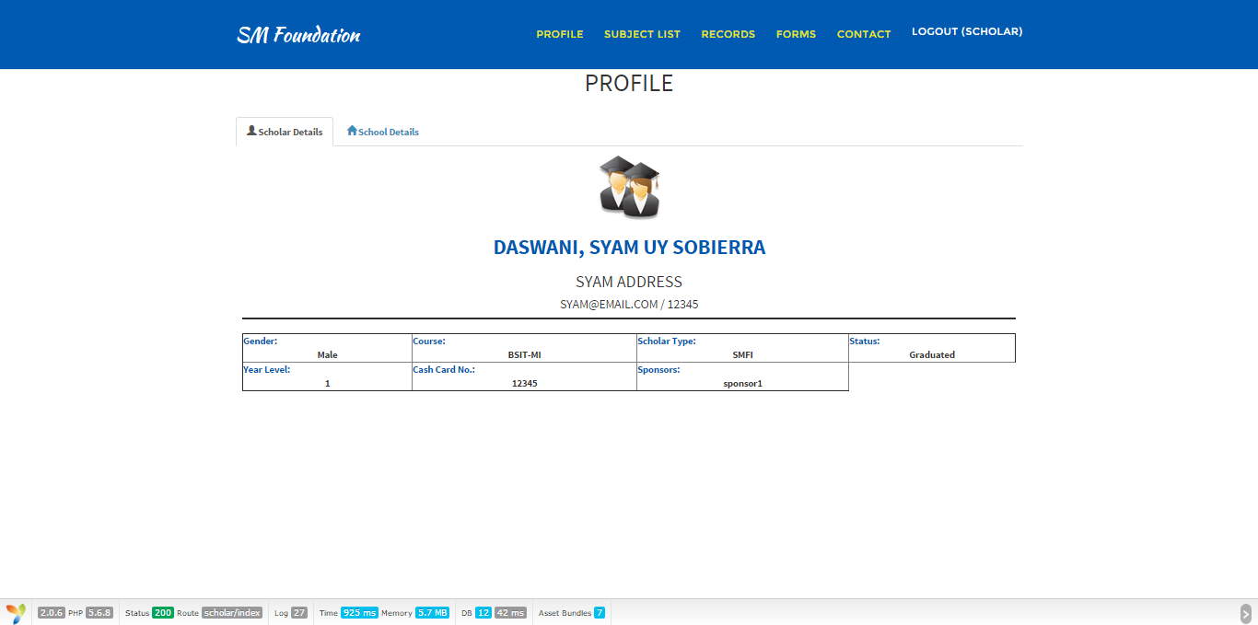

1. go to profile
2. click scholar details
   * 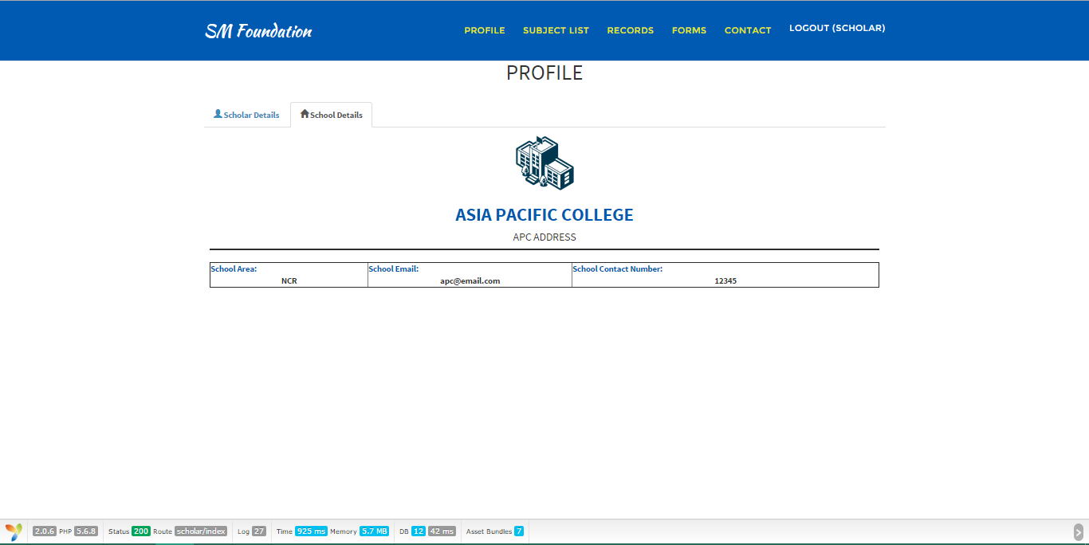View profile (school)
3. Go to profile
4. click school details
   * 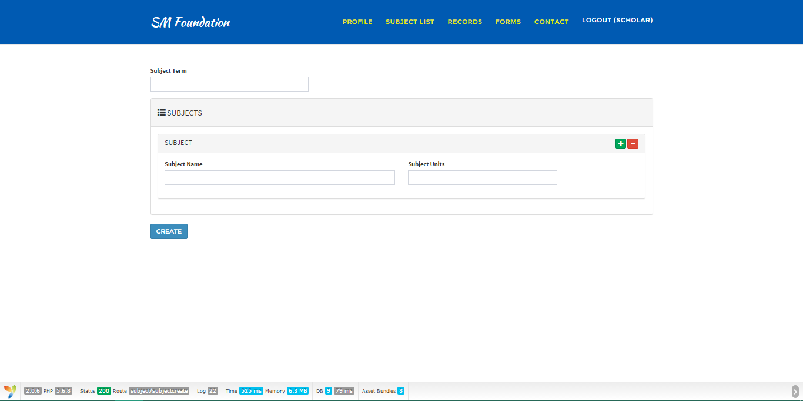View and create subjects
5. go to subject list for viewing
6. if creating a subject: fill out required information
   1. press create
   * 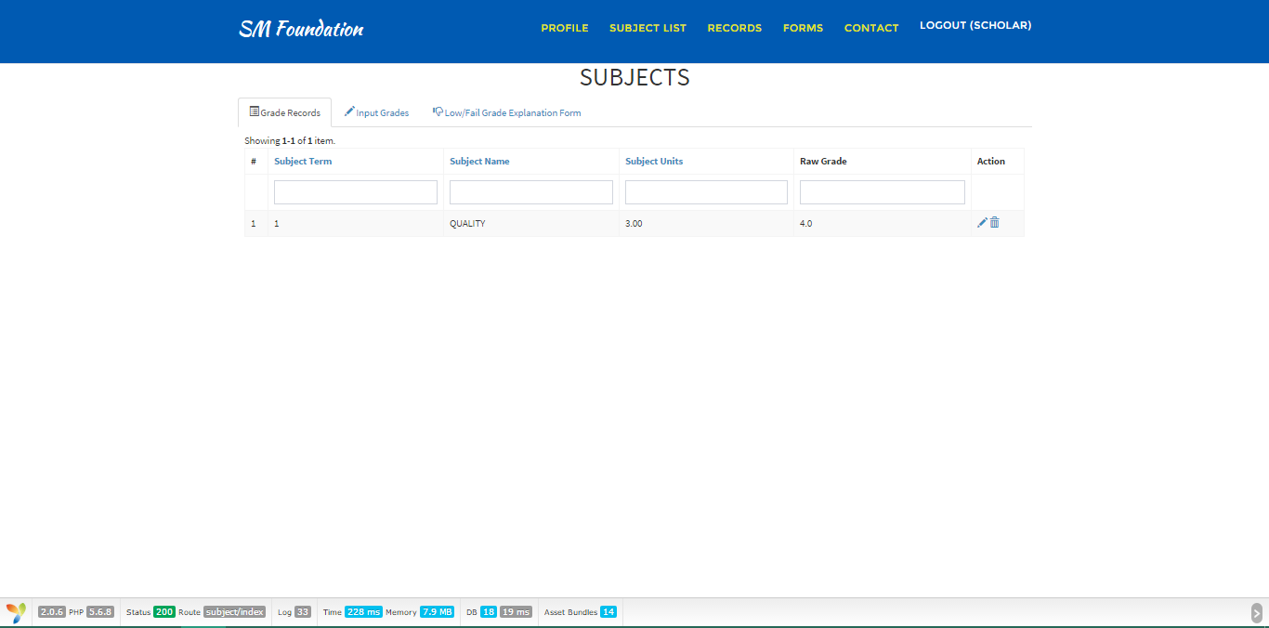view grades
   1. go to records > grades
   2. click grade records tab
   * 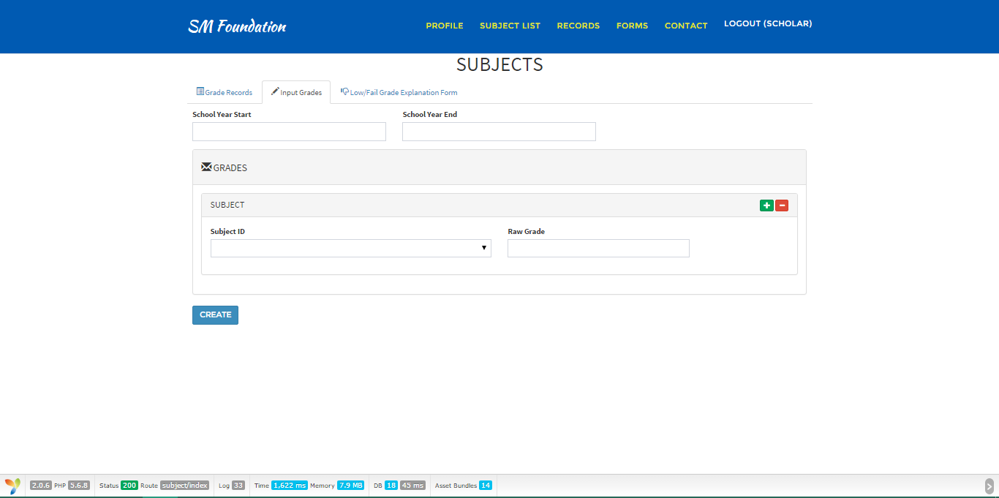create grades
   1. Go to records > grades
   2. switch to input grades tab
   3. fill out required information
   4. click create
   * 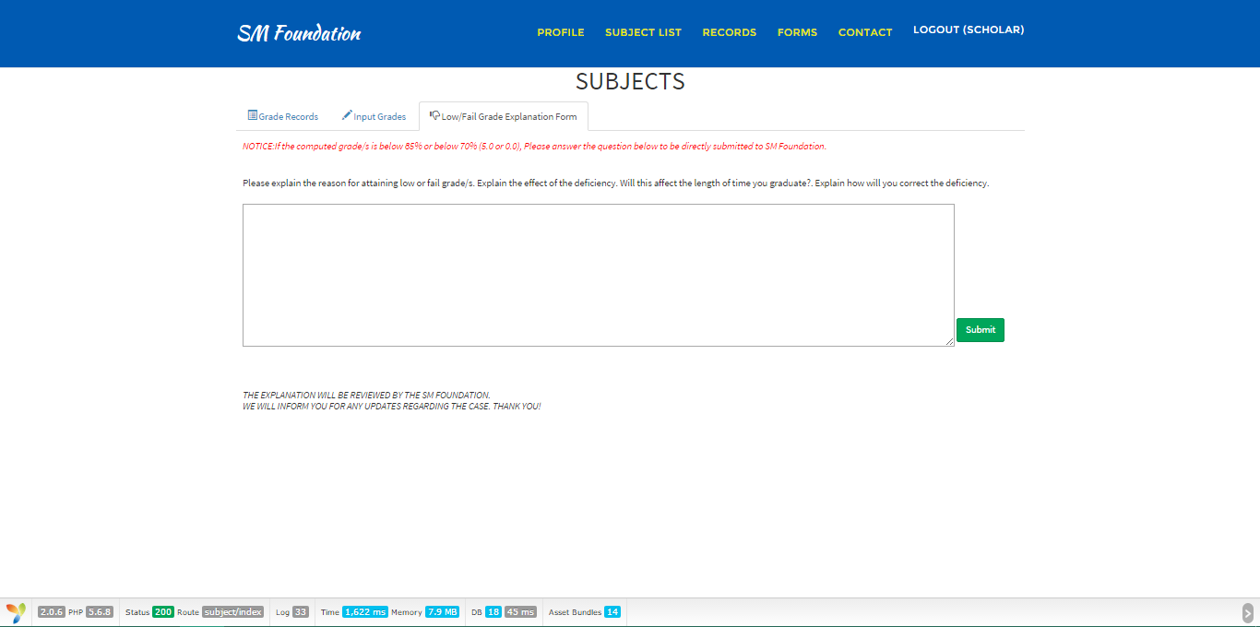Low/fail grade explanation form
     1. go to records > grades
     2. switch to low.fail grade explanation form tab
     3. explain the reason
     4. hit submit
   * 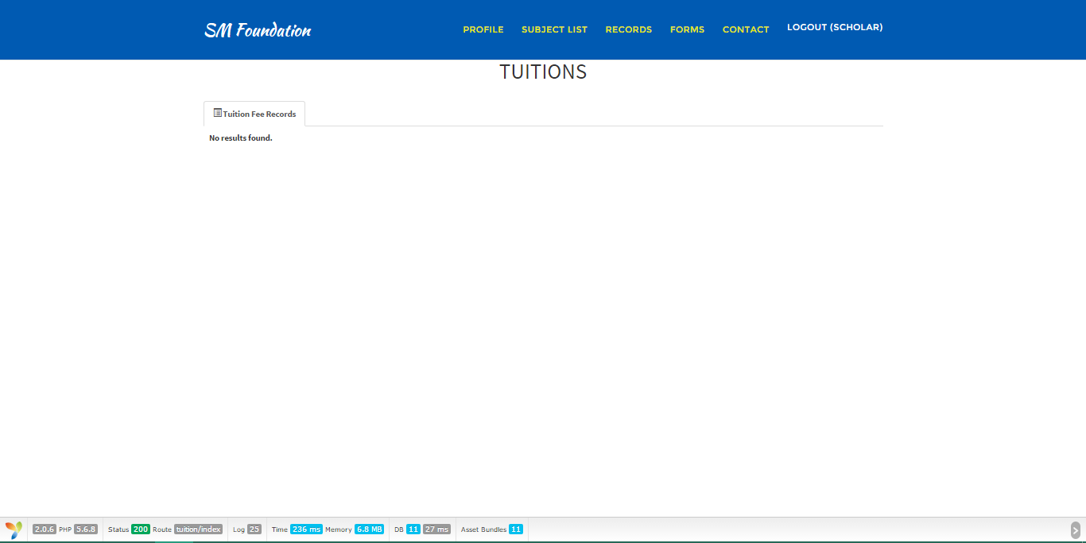view tuition fee records
     1. Go to records
     2. click view tuition fees picture menu
   * 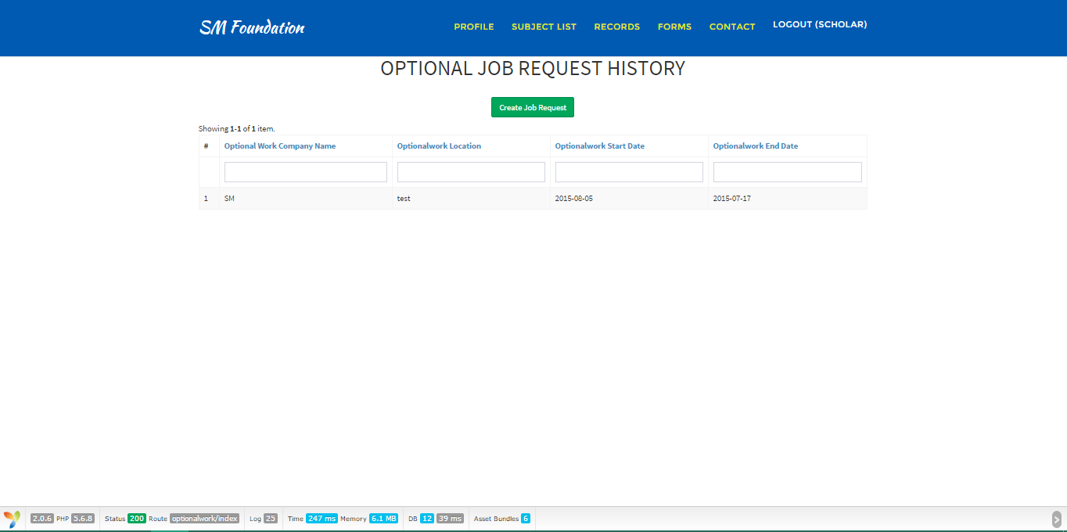create optional job request
     1. go to forms
     2. click the summer or christmas jobs menu
     3. click the create job request button
     4. fill out required fields
     5. hit create
   * 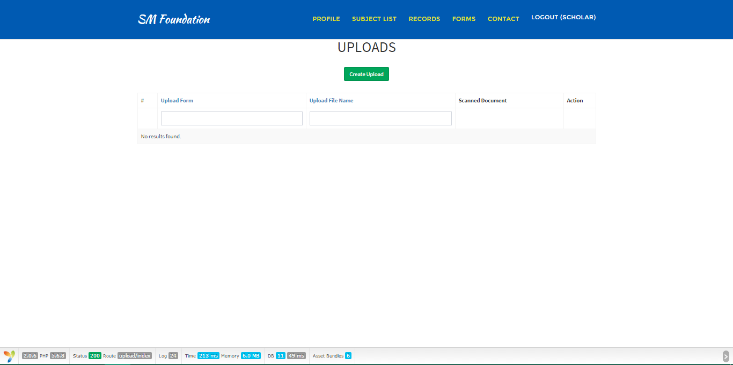Upload form/s
     1. go to forms
     2. click upload menu
     3. press the create upload button
     4. fill out the required fields
     5. browse for the file you want to upload
     6. create
   * View Allowance
   * View Benefits
   * 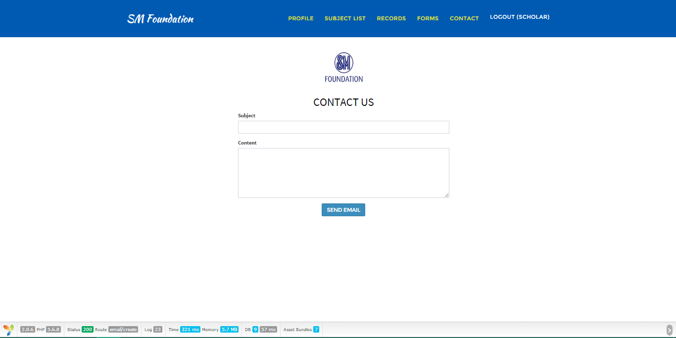contact sm foundation
     1. Go to contact
     2. input subject
     3. fill out the content
     4. send email
   * 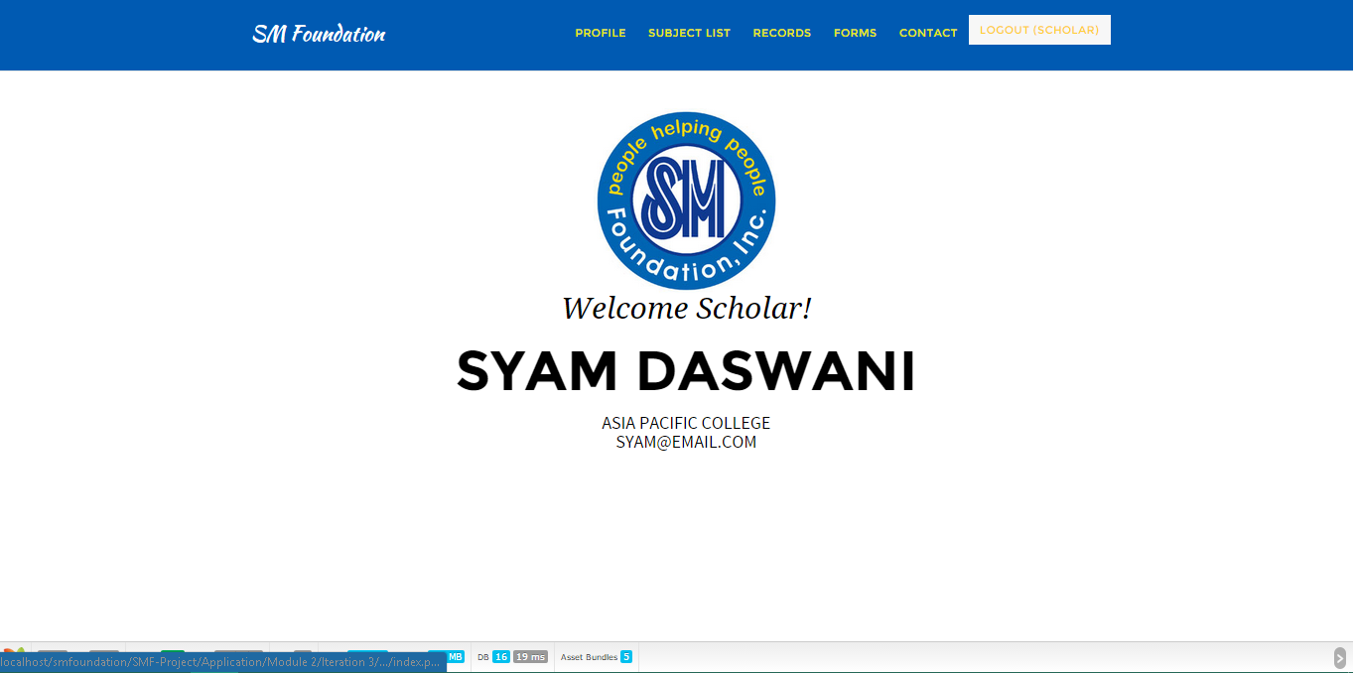Logout
   1. hit the logout

* Back-end
  + 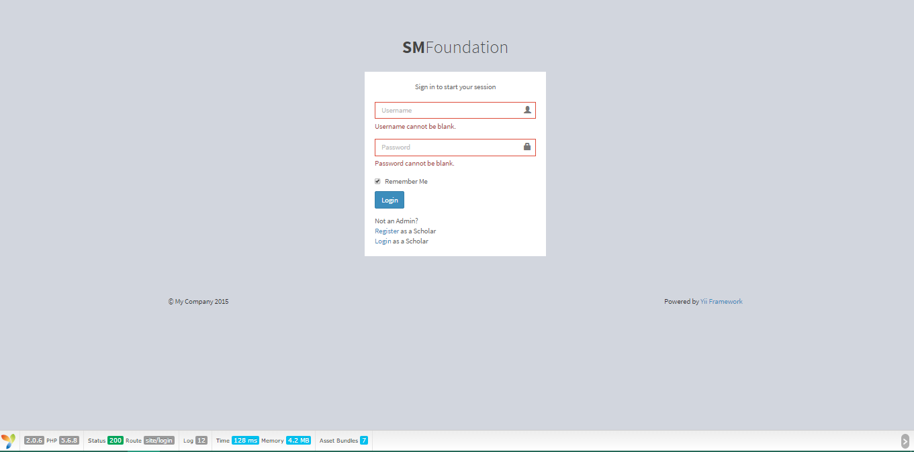Login
  + 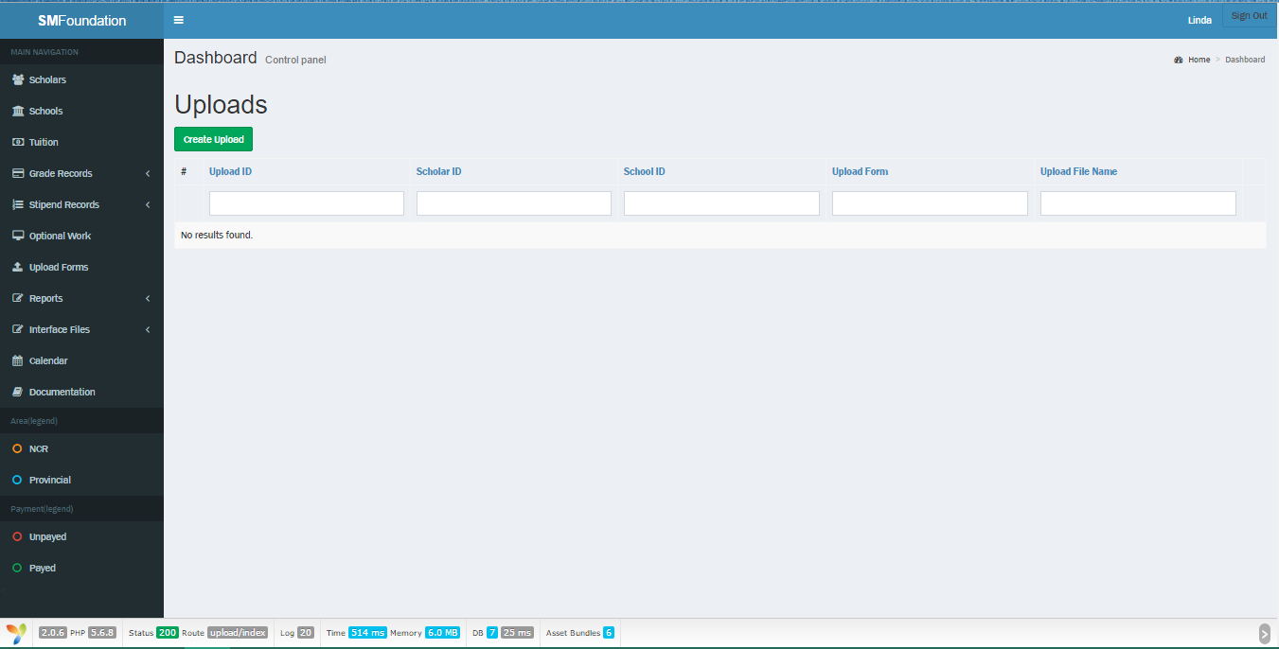upload requirements
  + Logout
  + Create record
    - Scholar

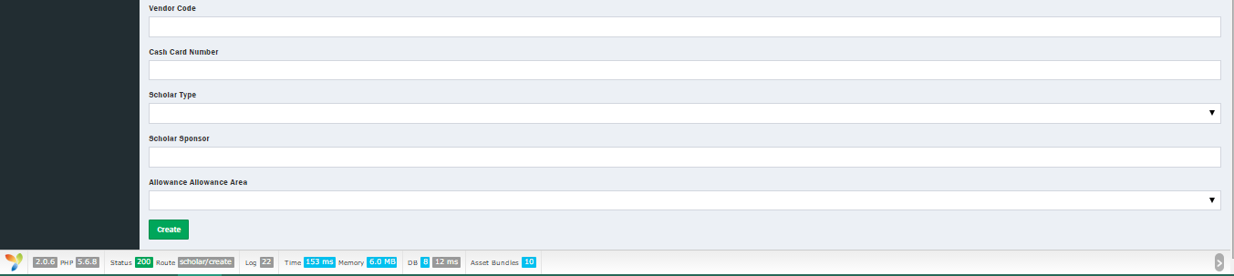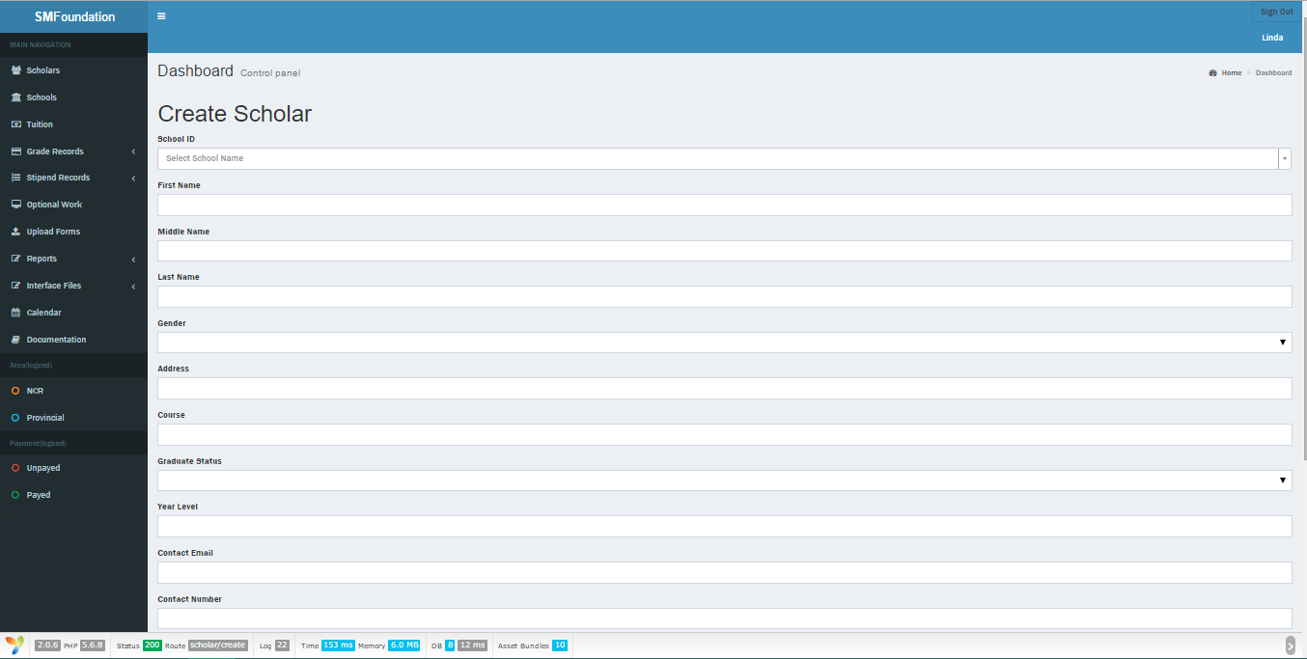

* + - 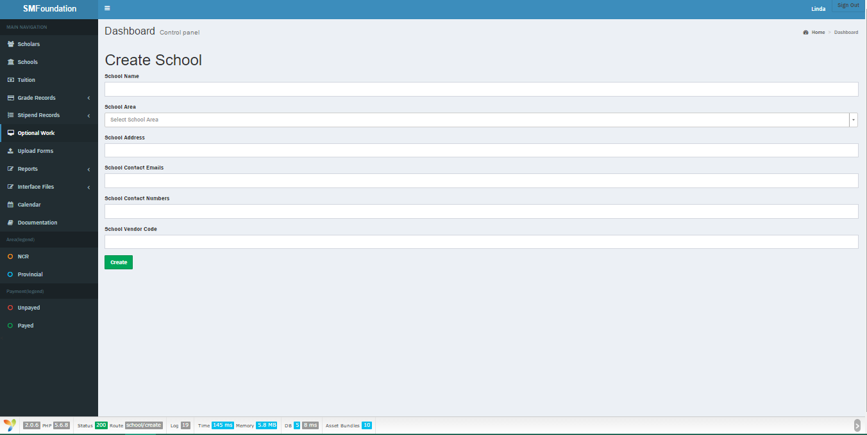School
    - 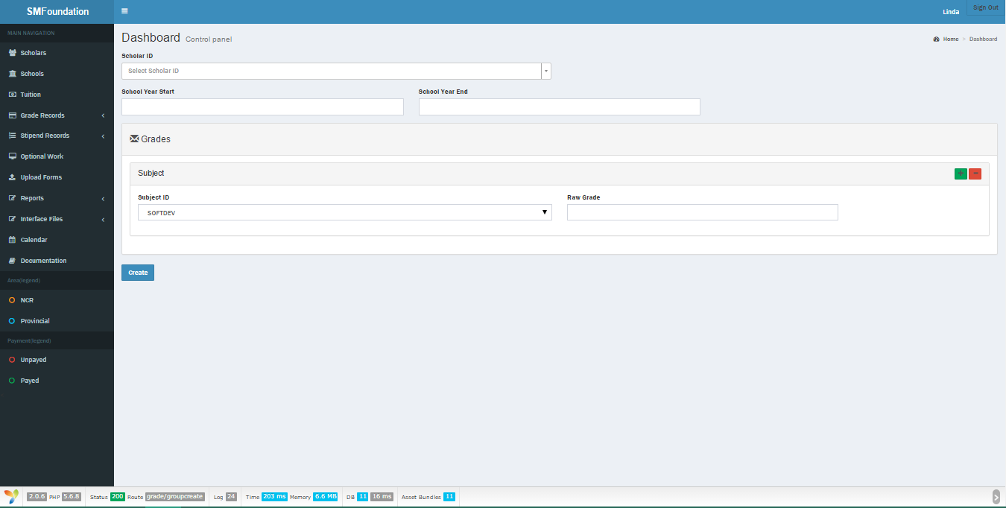Grade
    - 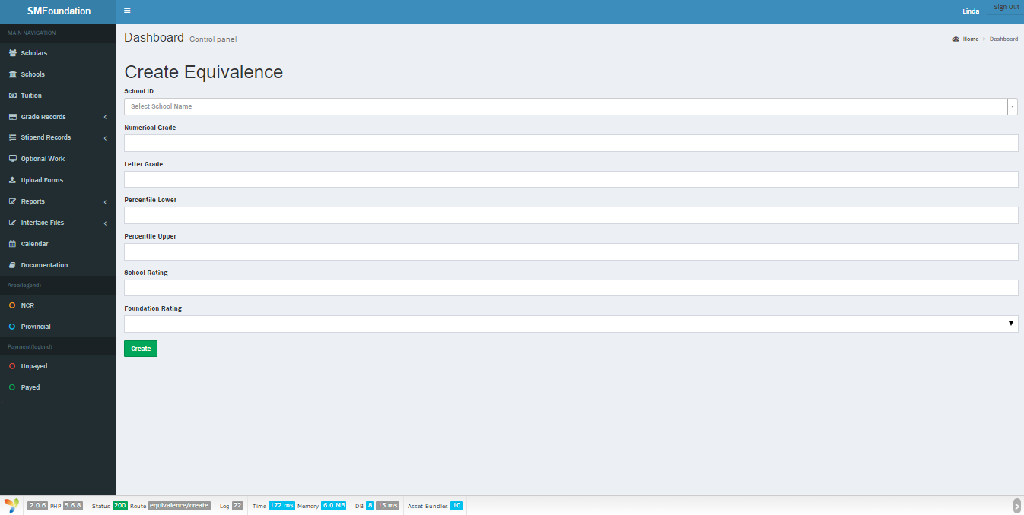Grade Equivalence
    - 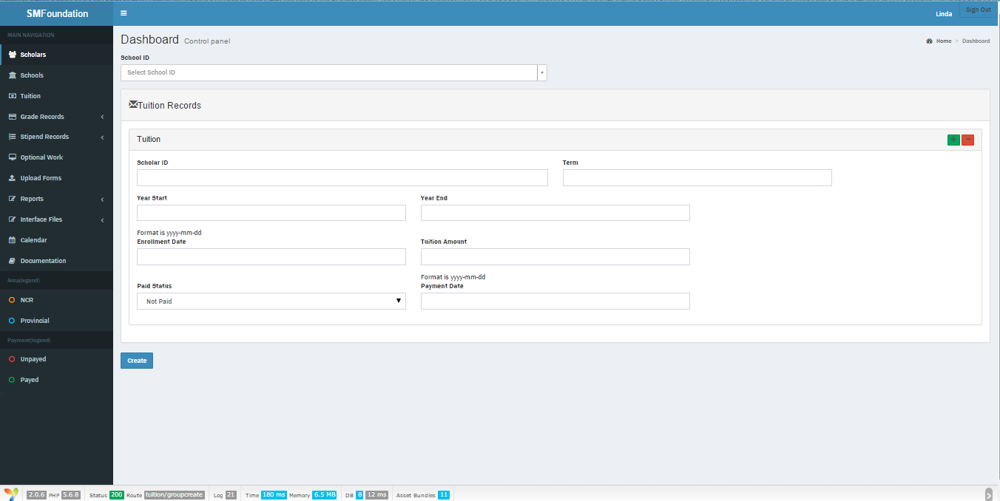Tuition
    - 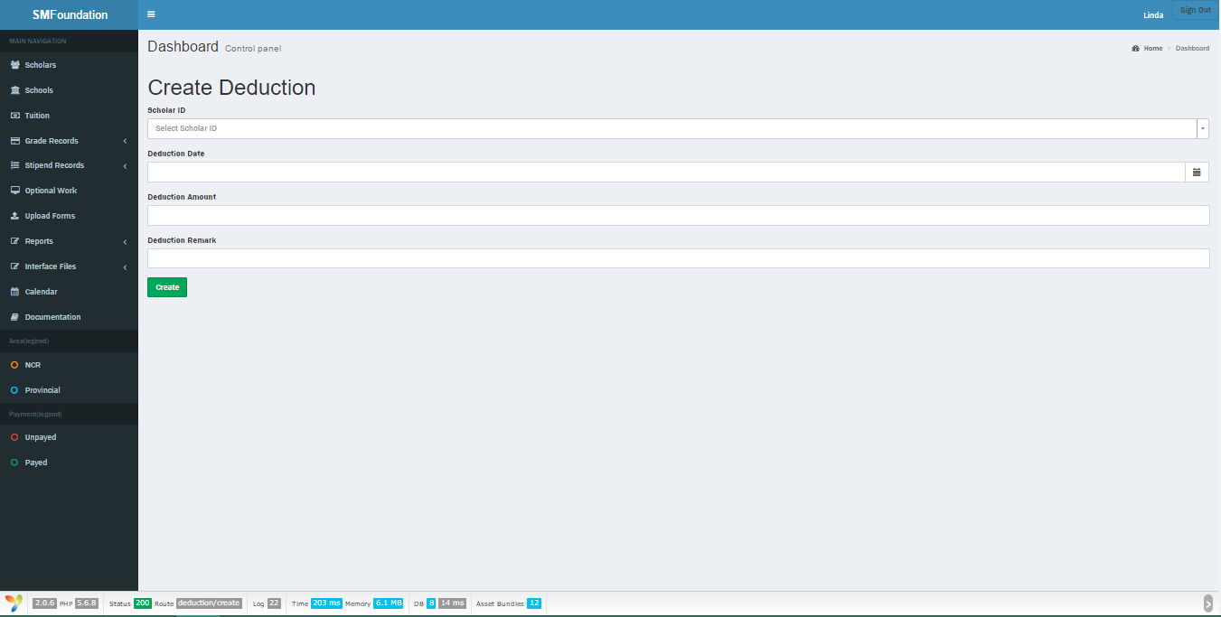Deduction
    - 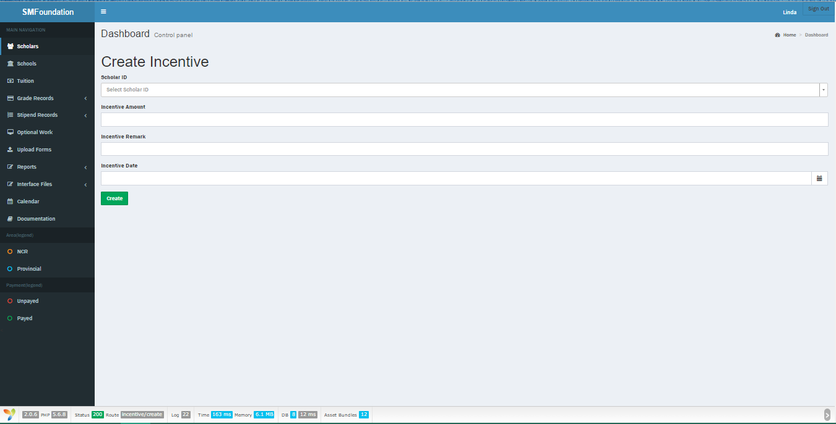Incentives
    - 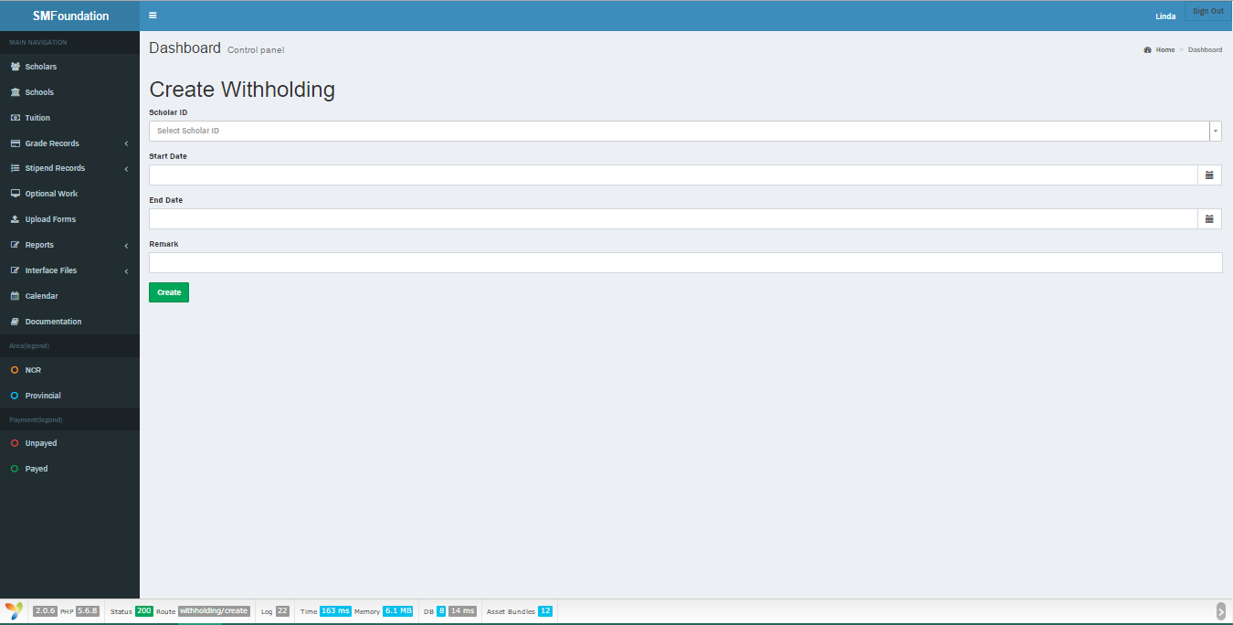Withholding
    - 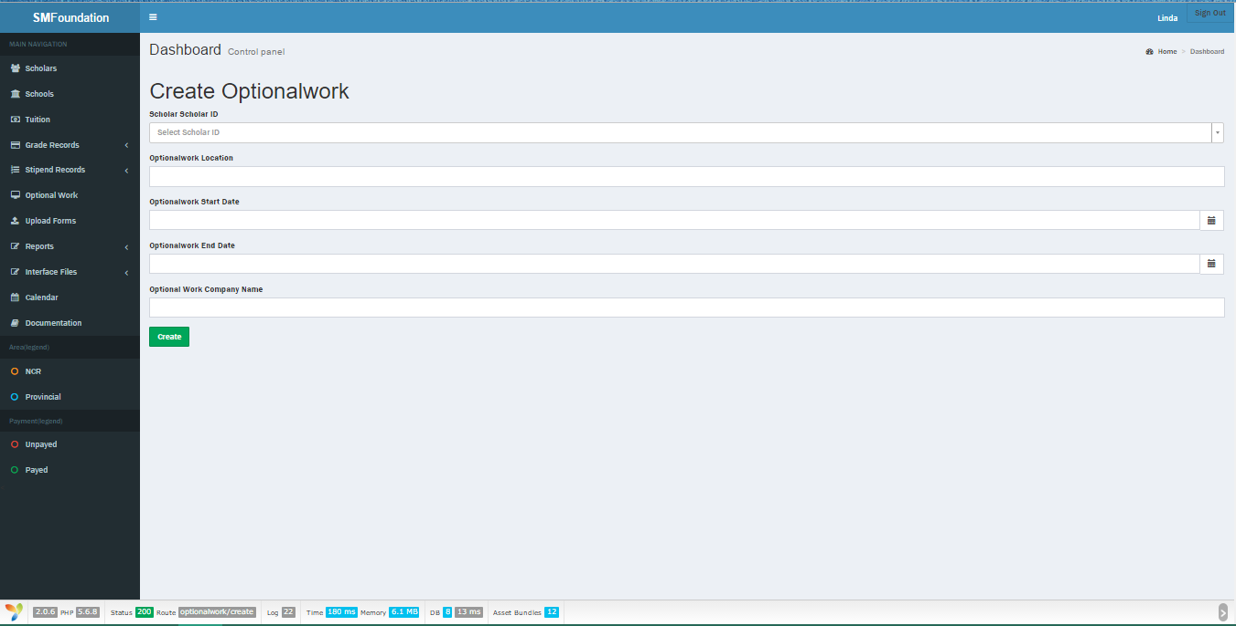Optional work
    - 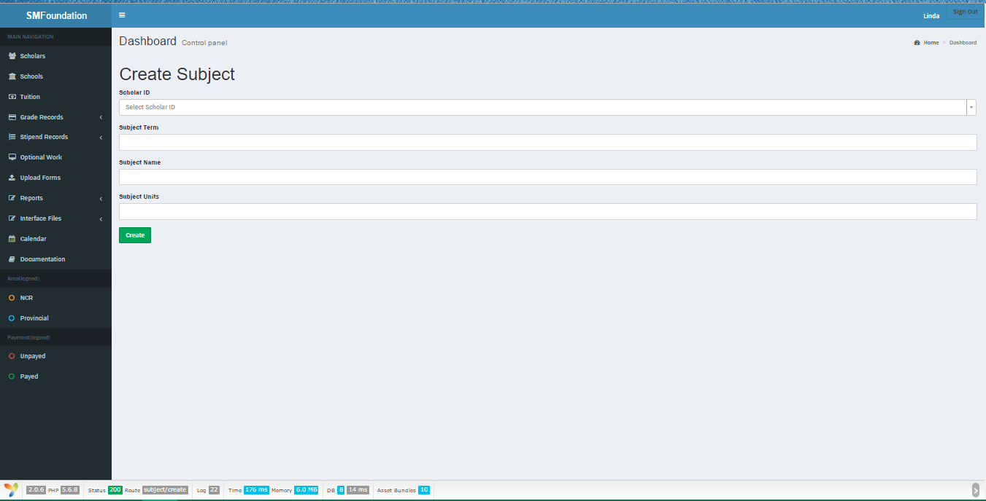Subject
  + Read record
    - 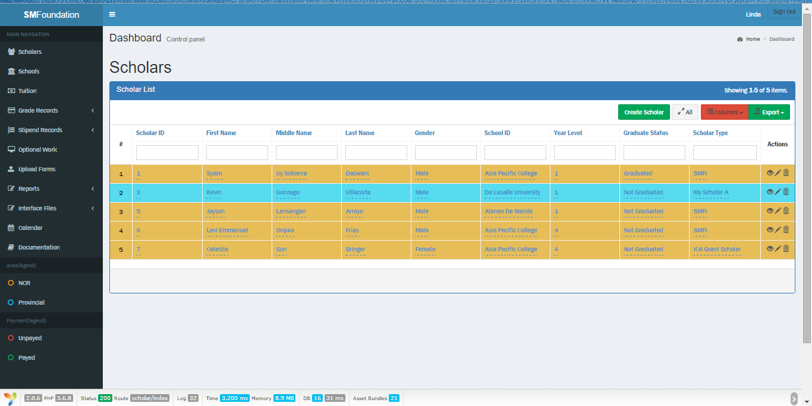Scholar
    - 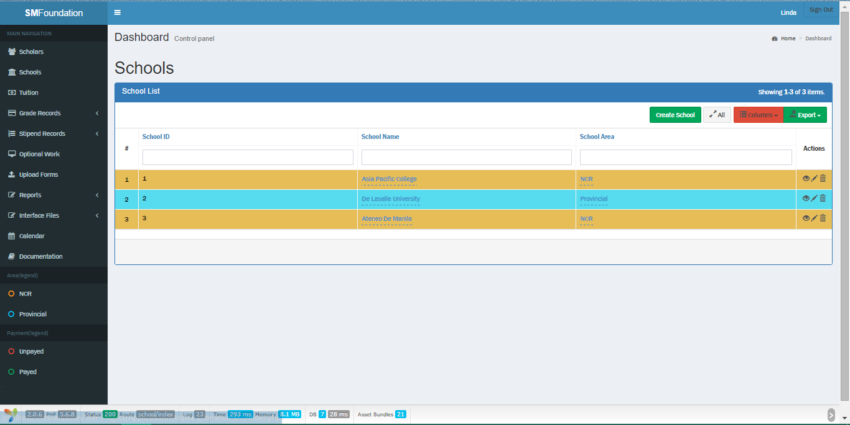School
    - Grade (Group by Schools)

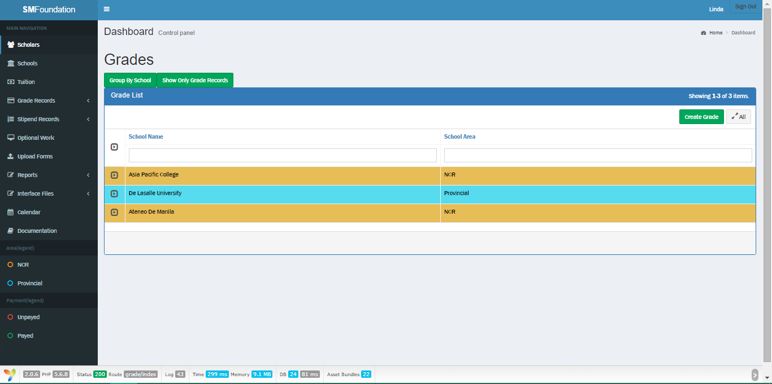

* 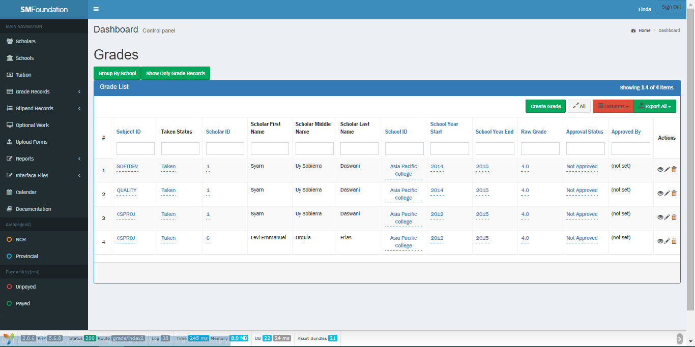Grade (Grades only)
  + - 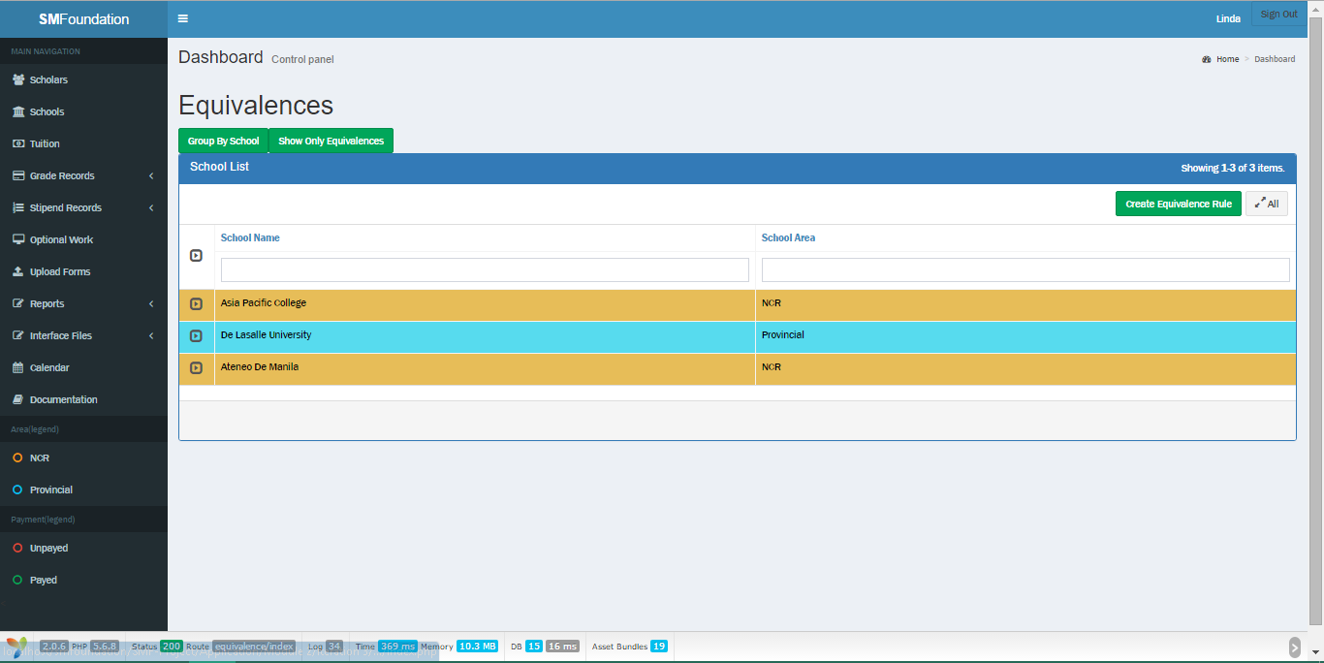Grade Equivalence (Group by school)
    - 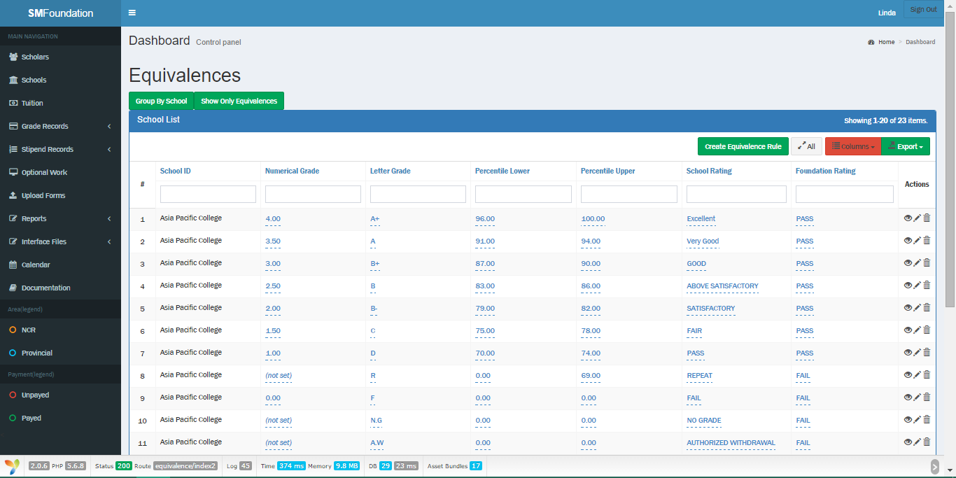Grade Equivalence (Equivalences only)
    - 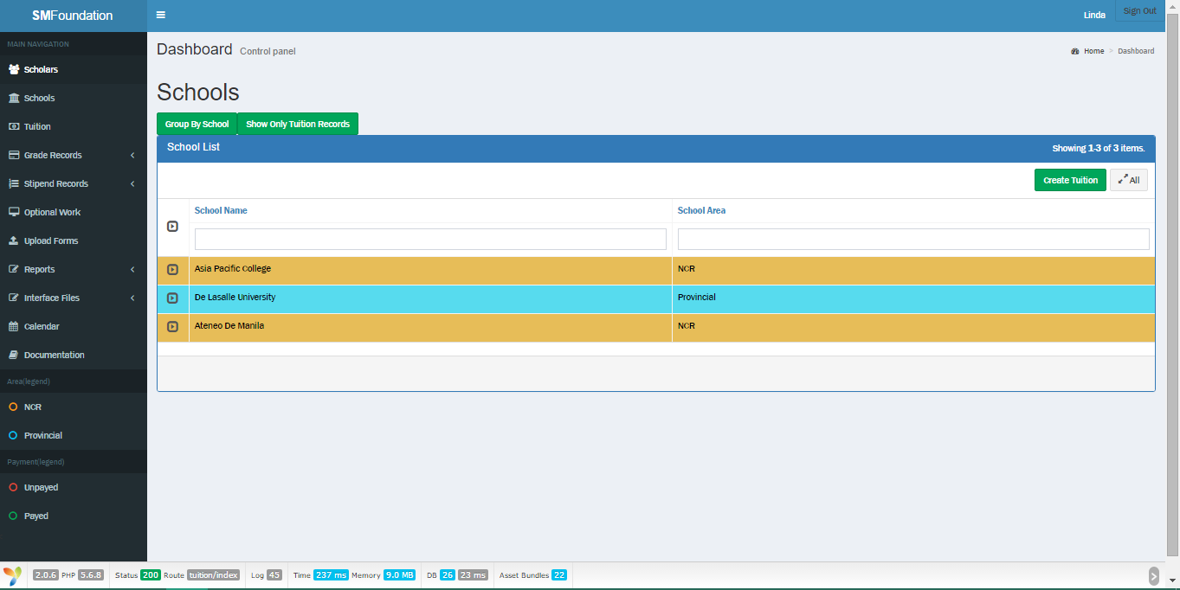Tuition (Group by Schools)
    - 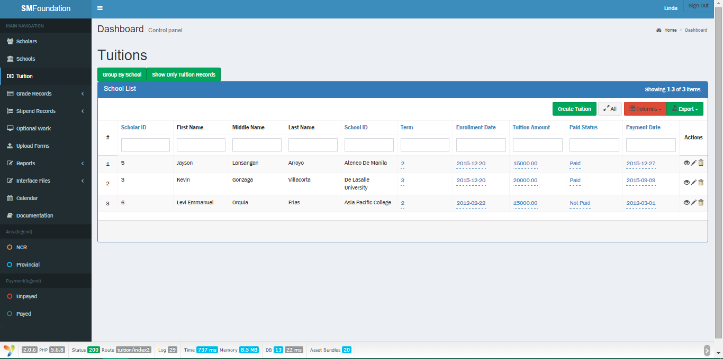Tuition (Tuition only)
    - 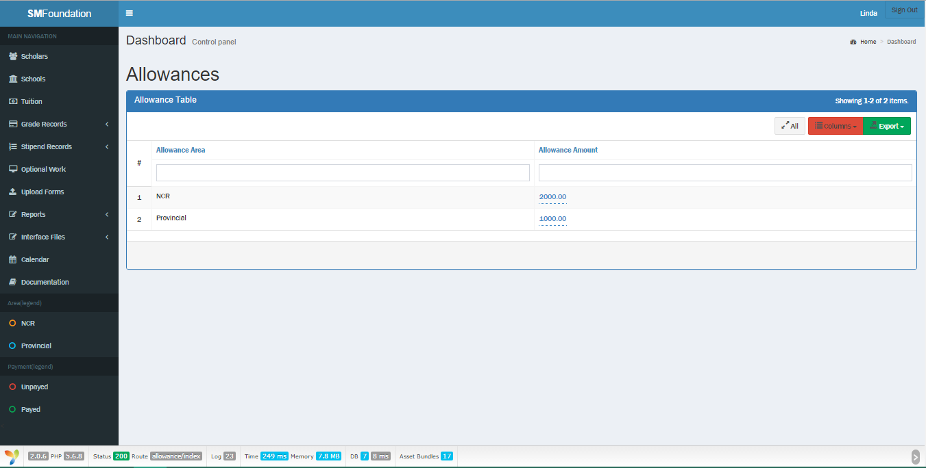Allowance
    - 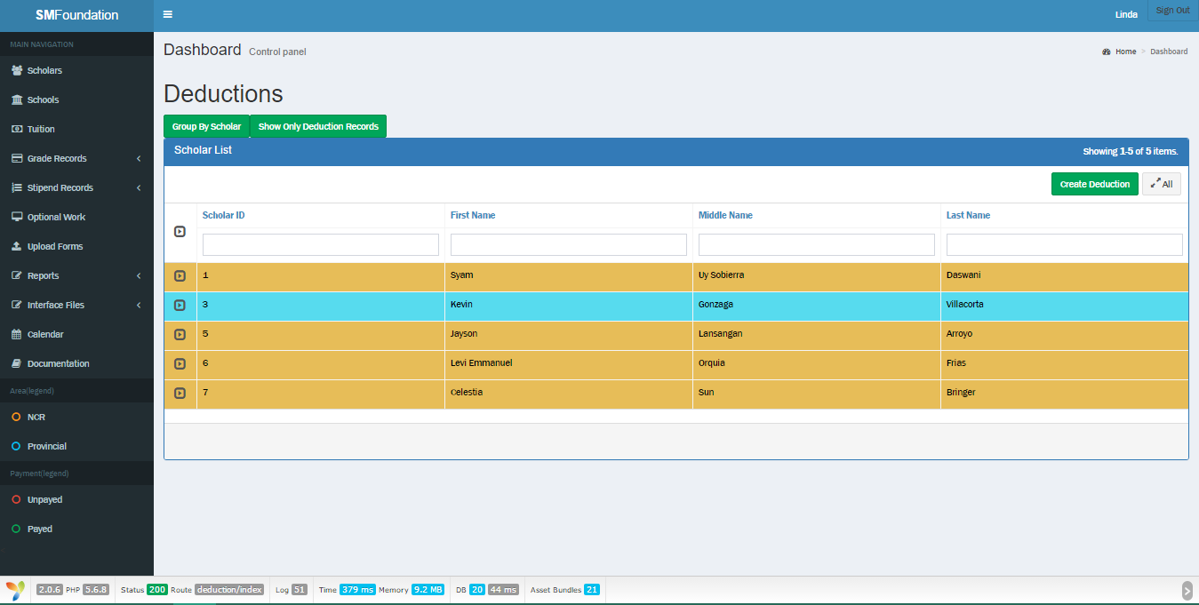Deductions (Group by Scholar)
    - 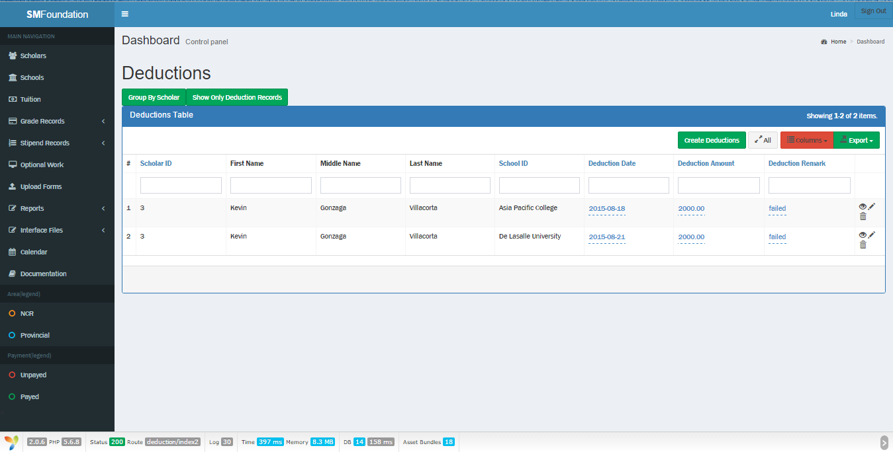Deductions (Deductions only)
    - 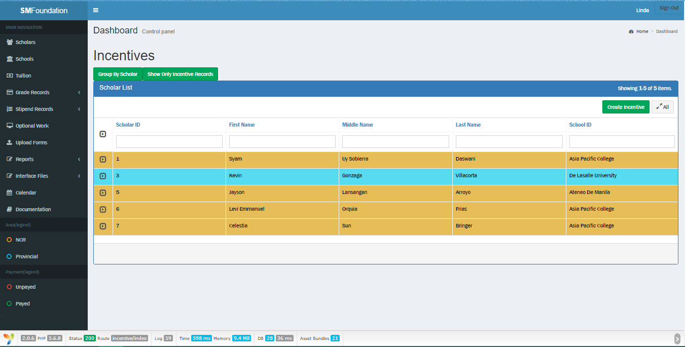Incentives (Group by Scholar)
    - 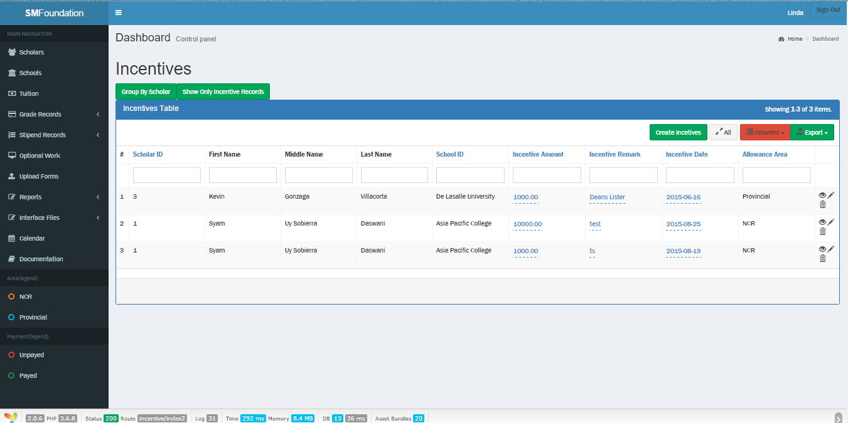Incentives (Incentives only)
    - 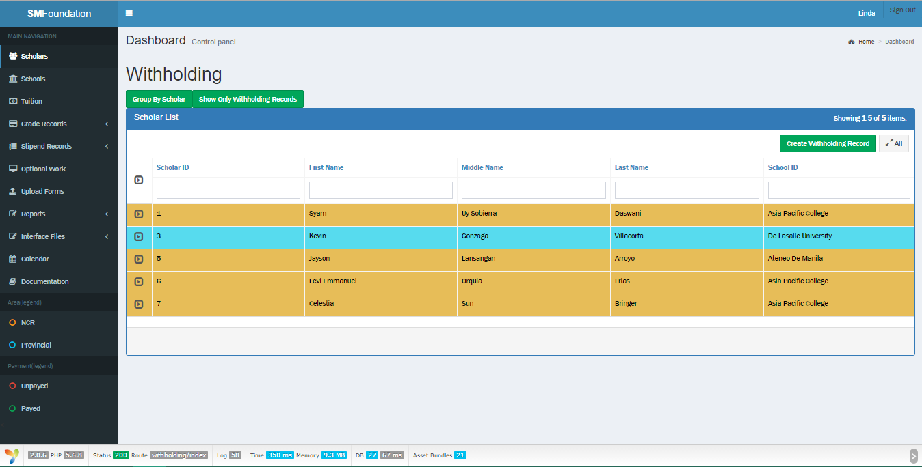Withholding (Group by Scholar)
    - 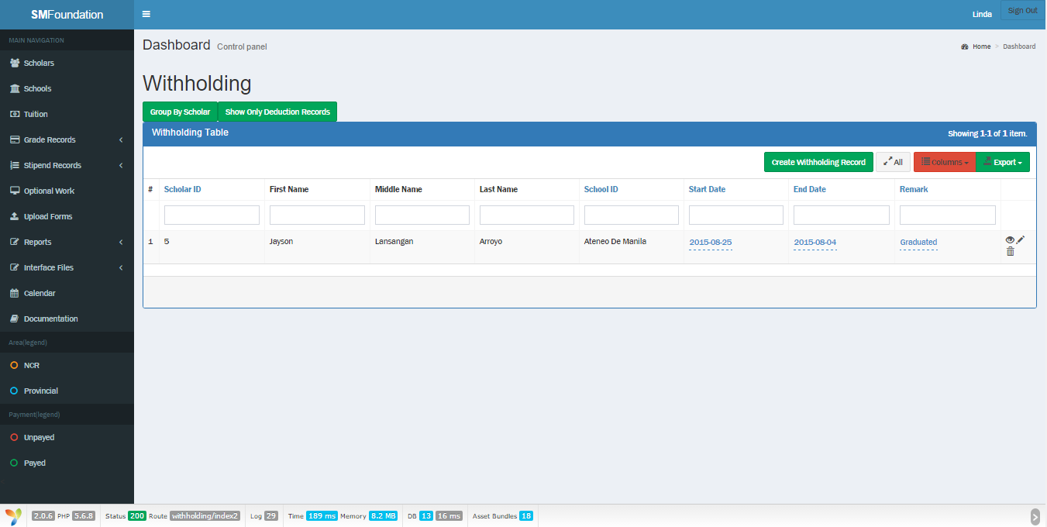Withholding (Deductions only)
    - Optional work (Group by Scholar)

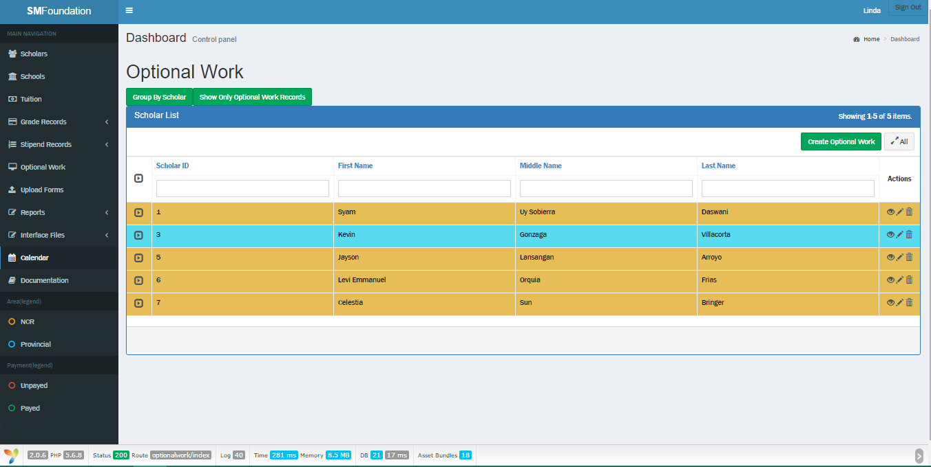

* + - 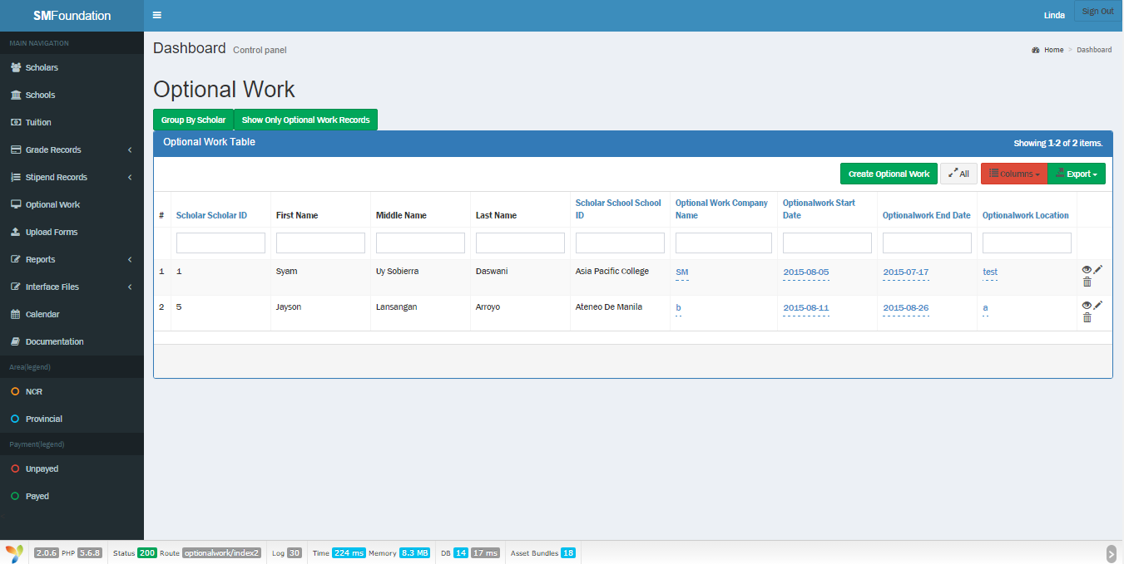Optional Work (Optional Work only)
    - Calendar (Monthly)

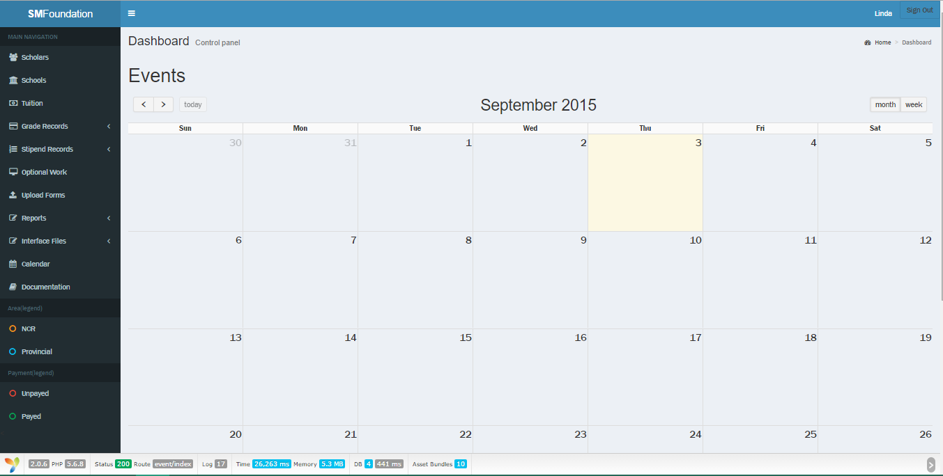

* + - 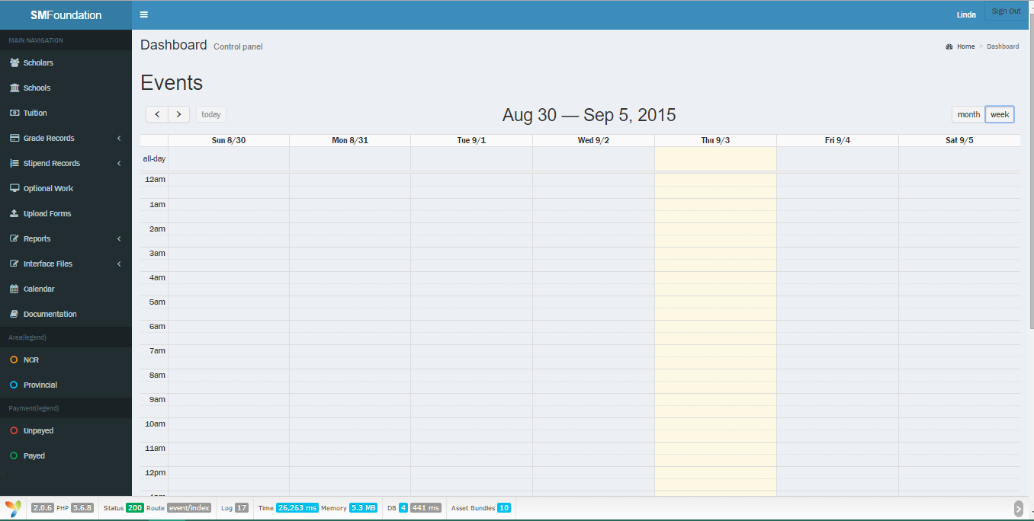Calendar (Weekly)
    - 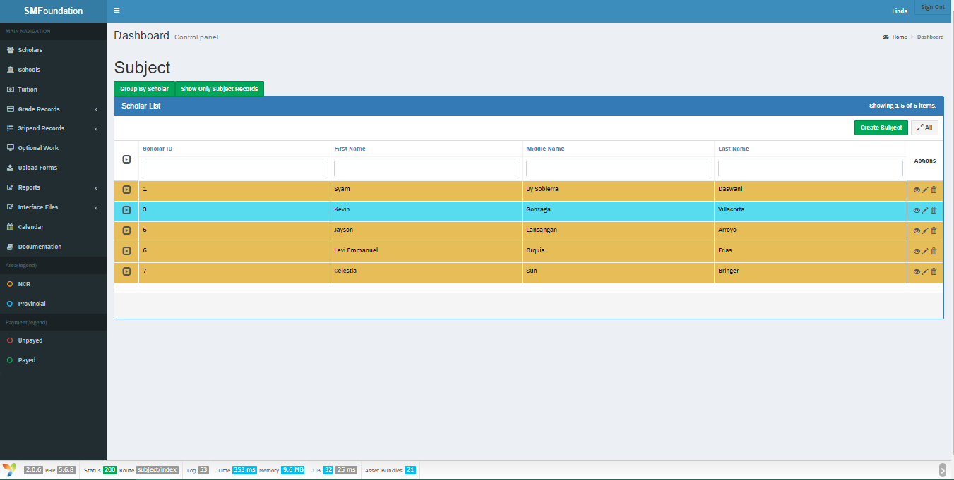Subject (Group by Scholar)
    - Subject (Subject records only)

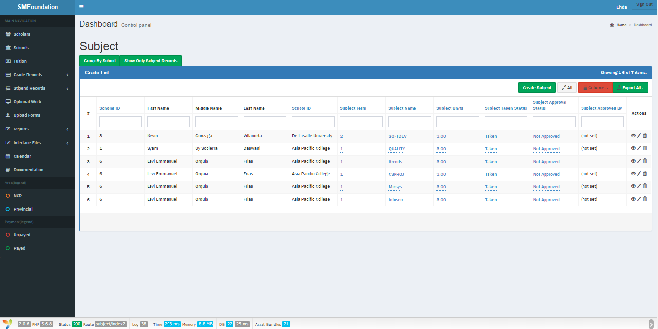

* + Update record
    - 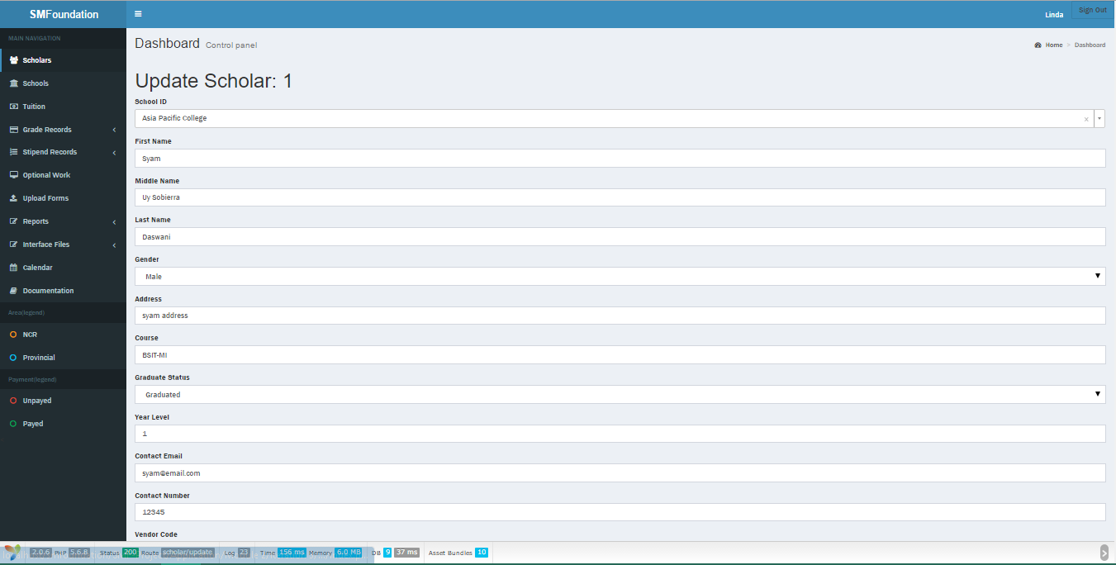Scholar
    - 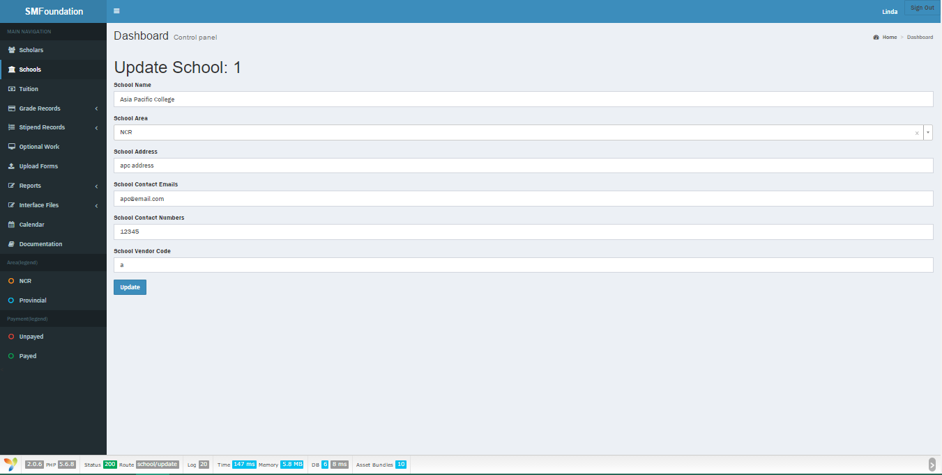School
    - 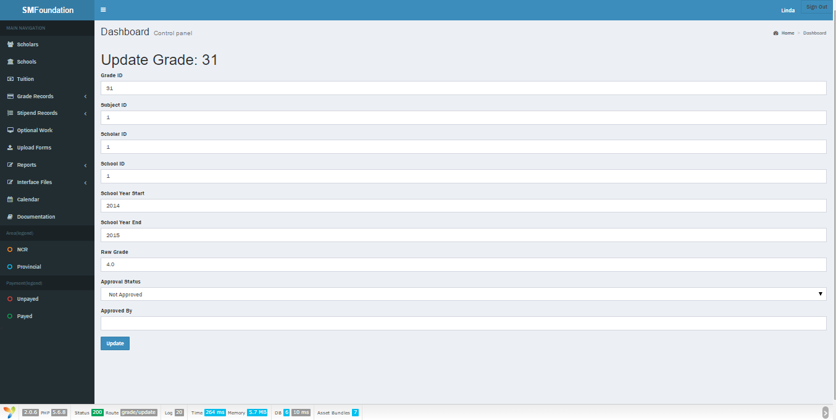Grade
    - 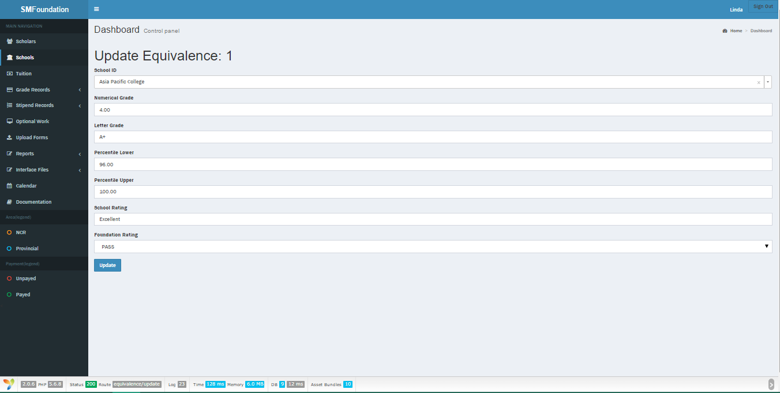Grade Equivalence
    - 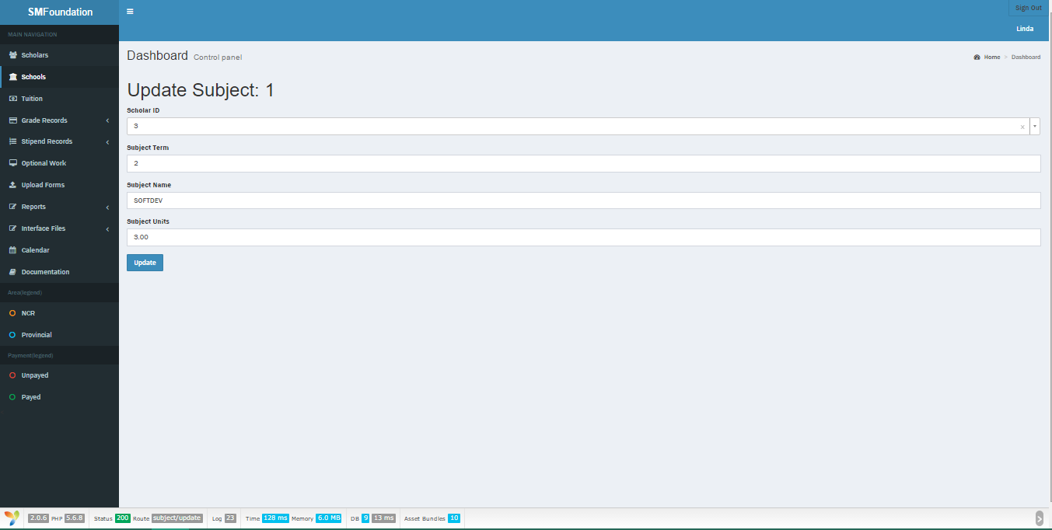Subject
    - 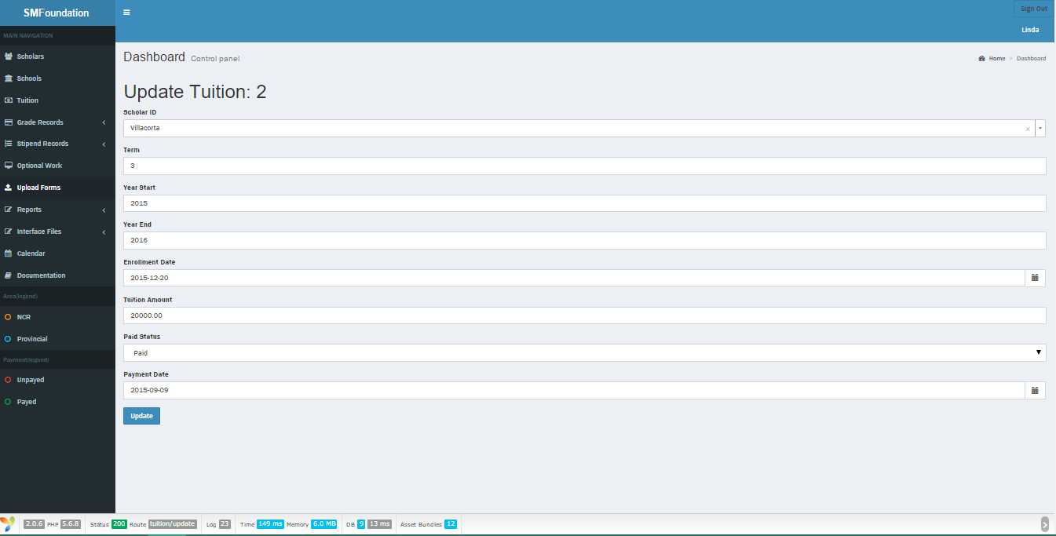Tuition
    - 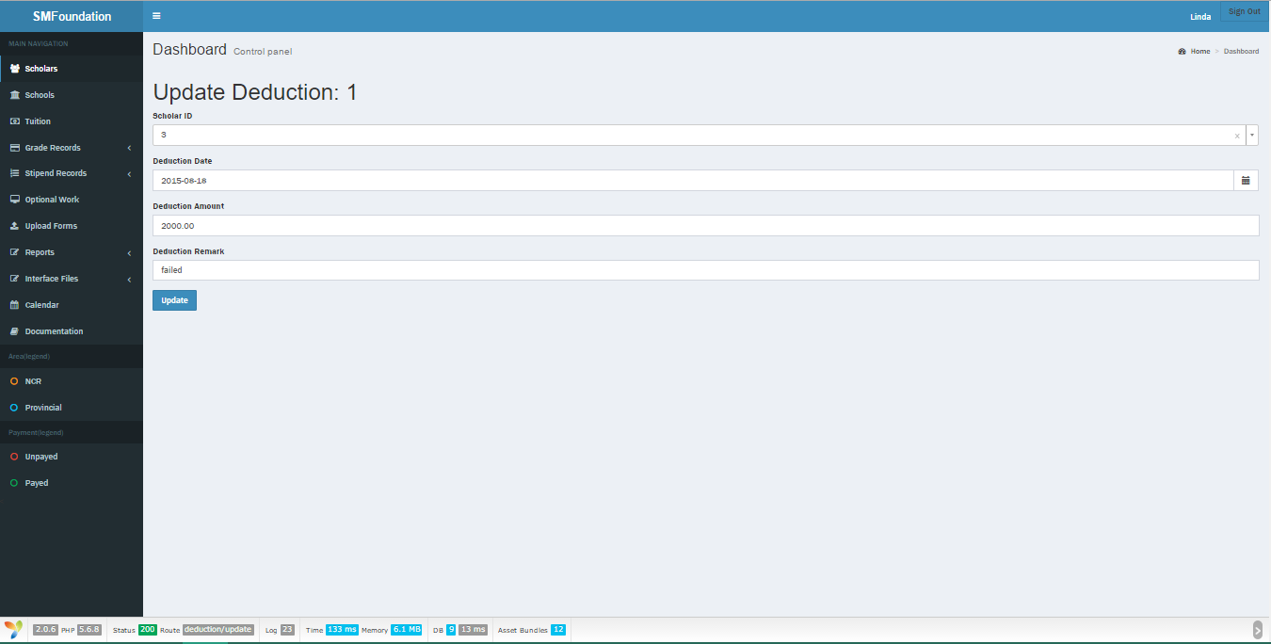Deduction
    - 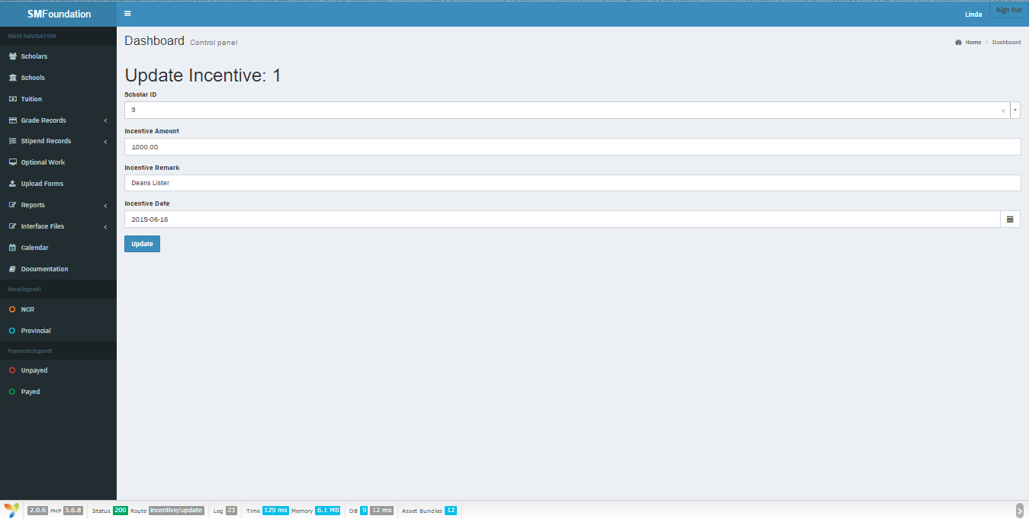Incentive
    - 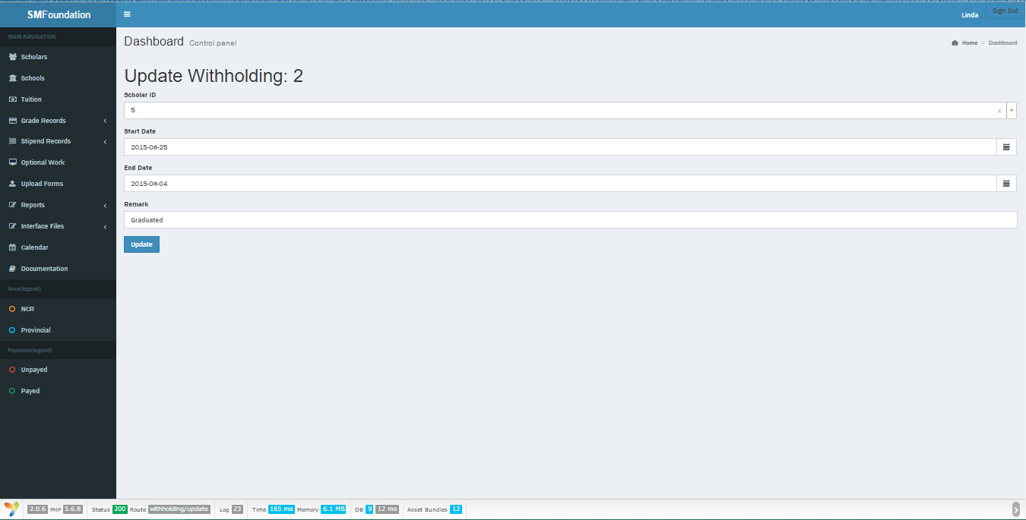Withholding
    - 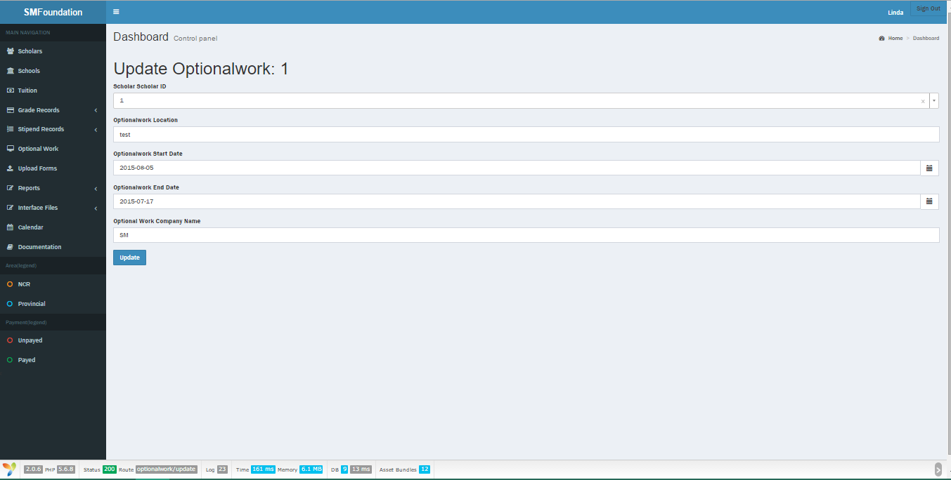Optional work
  + Delete record
    - 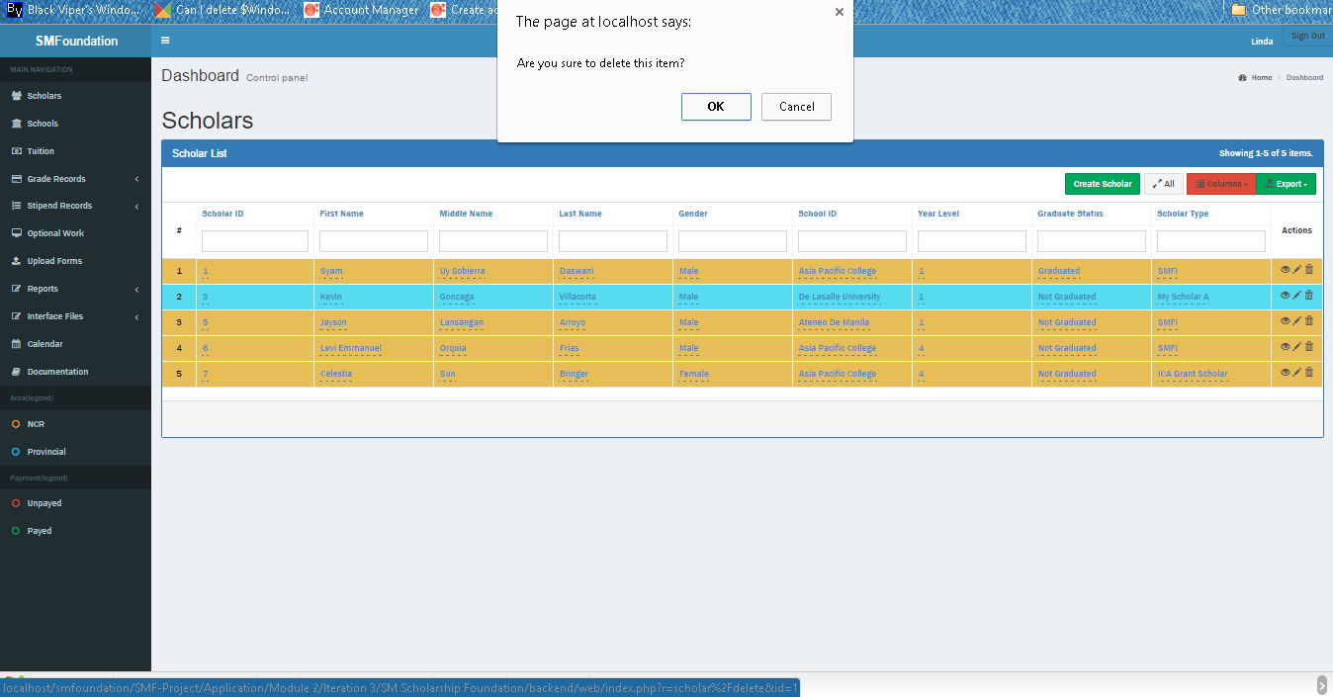Scholar
    - 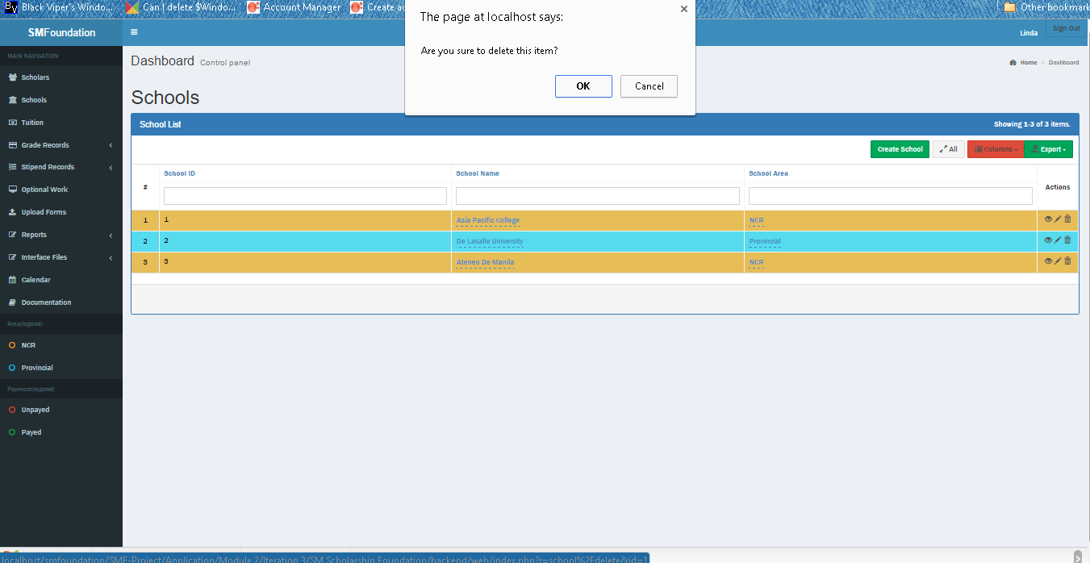School
    - Grade (Group by School)

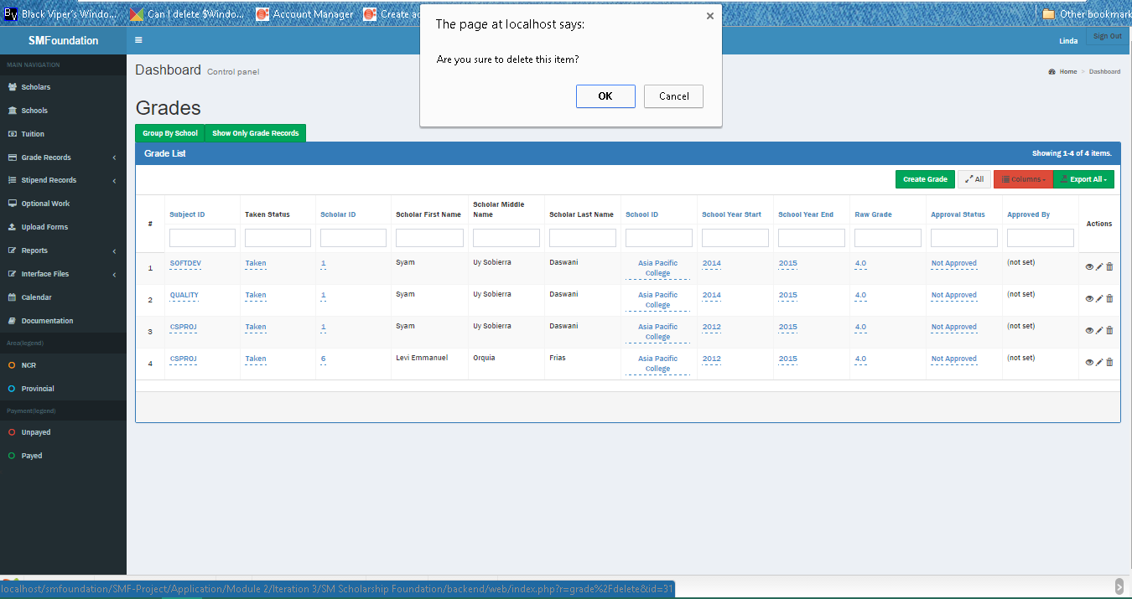

* + - Grade (Grades only)
    - Grade Equivalence (Group by School)

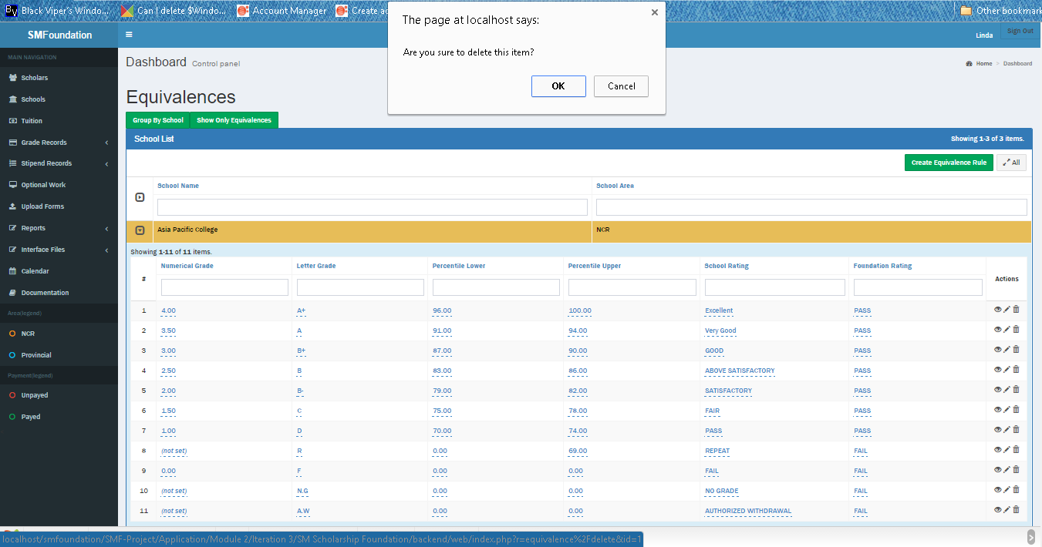

* + - 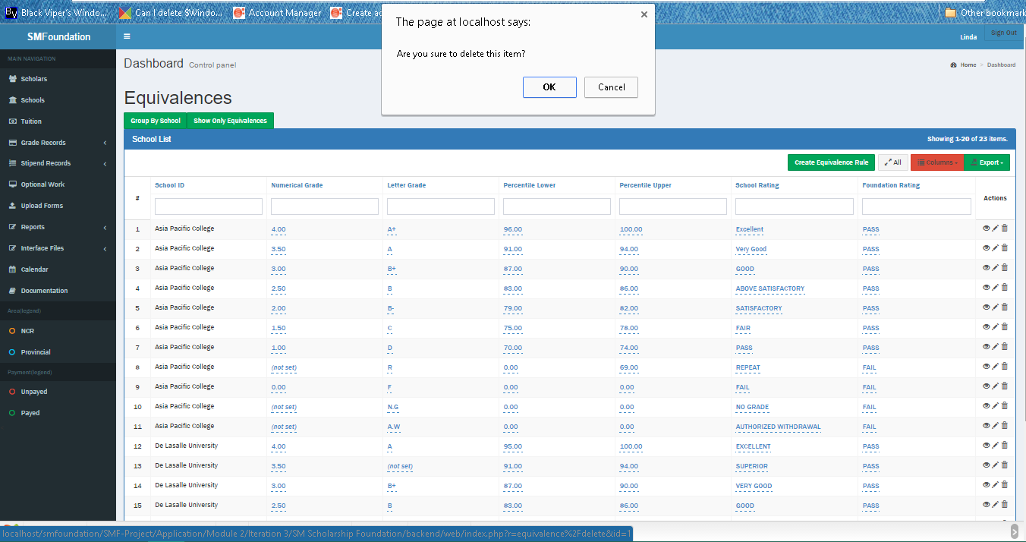Grade Equivalence (Equivalences only)
    - 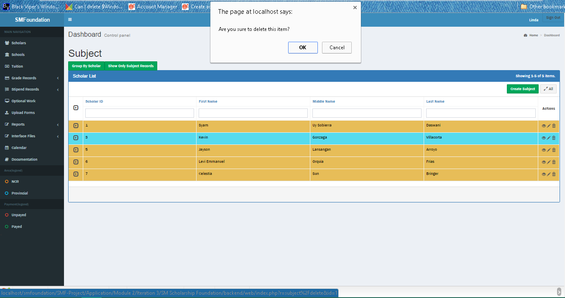Subject (Group by Scholar)
    - 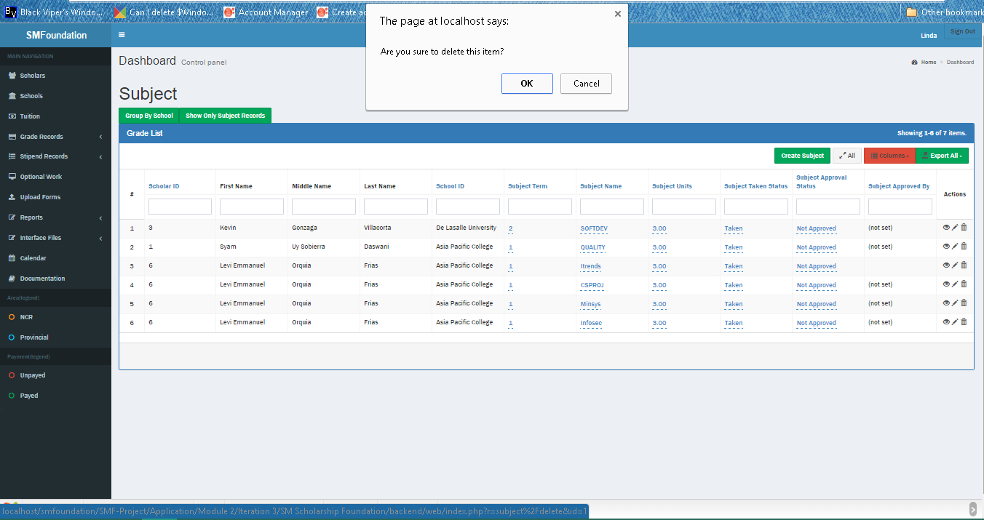Subject (Subjects only)
    - Tuition (Group by School)

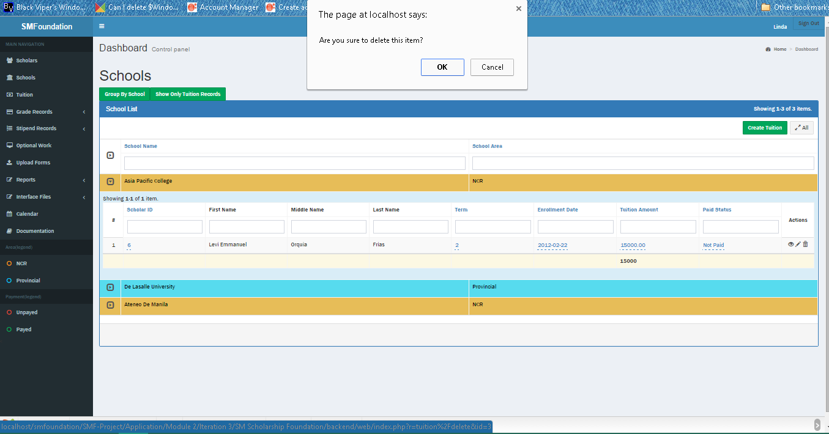

* + - Tuition (Tuition only)

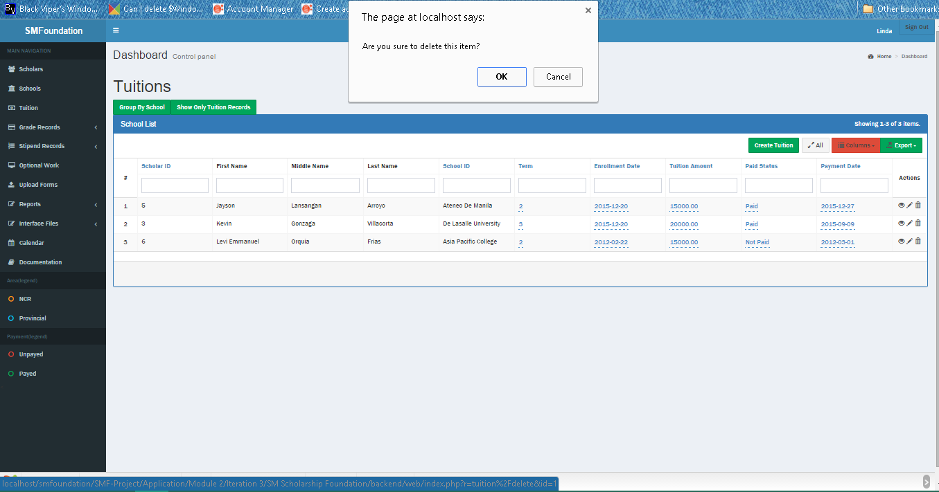

* + - 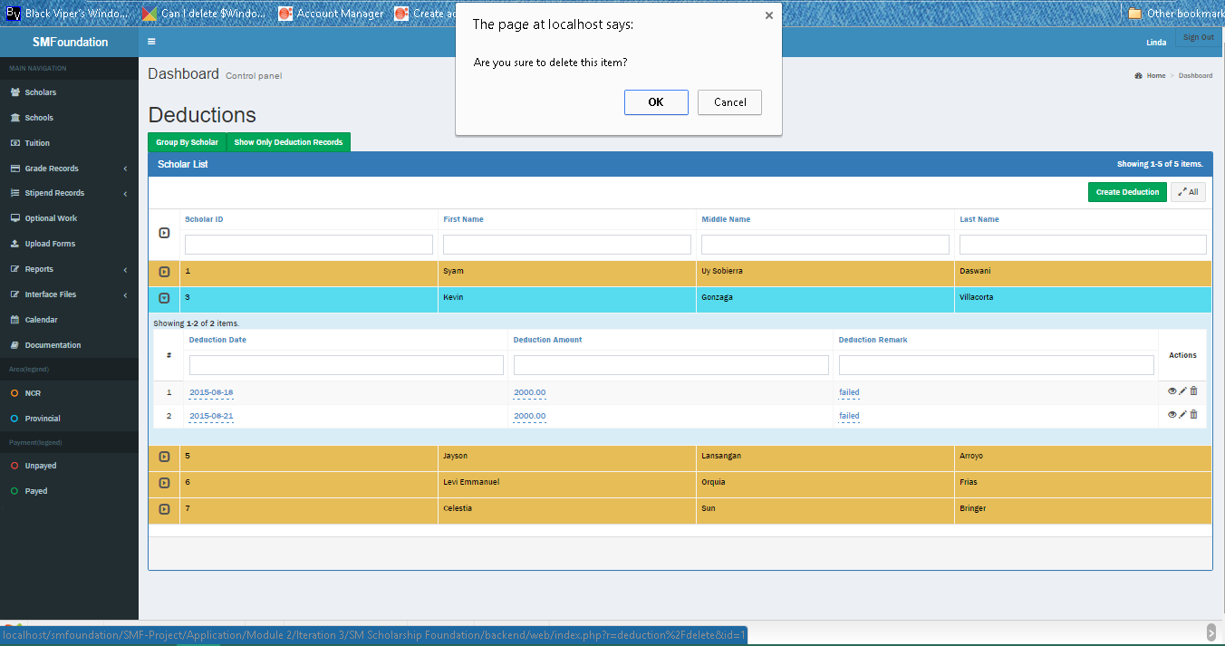Deduction (Group by Scholar)
    - Deduction (Deductions only)

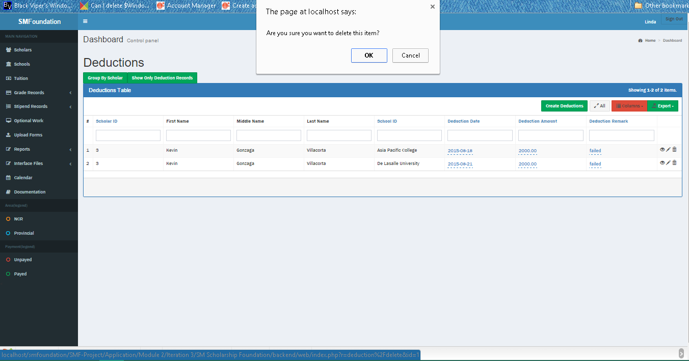

* + - Optional work (Group by Scholar)

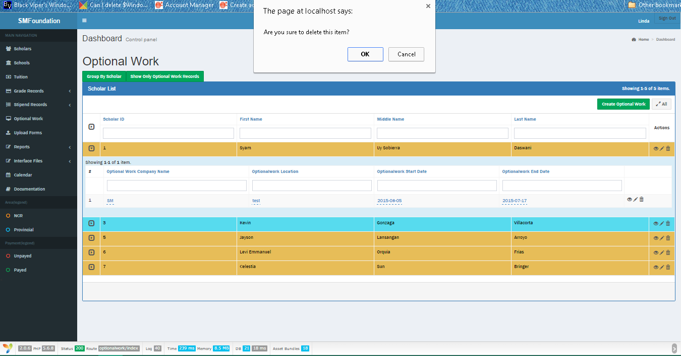

* + - 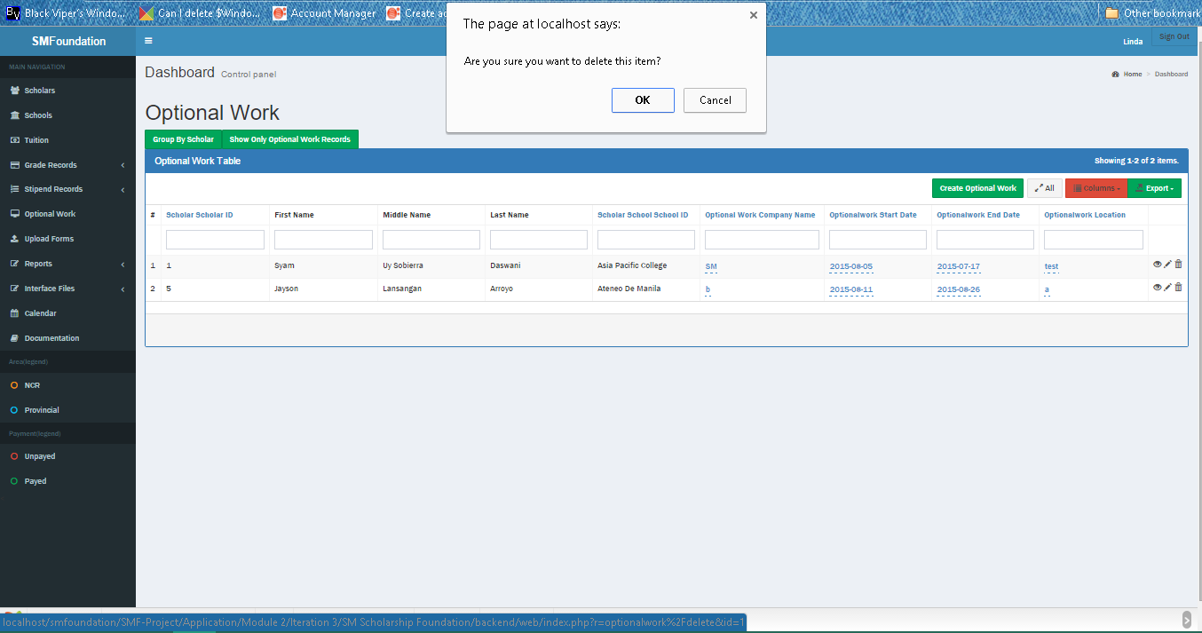Optional work (Works only)
  + Generate report
    - 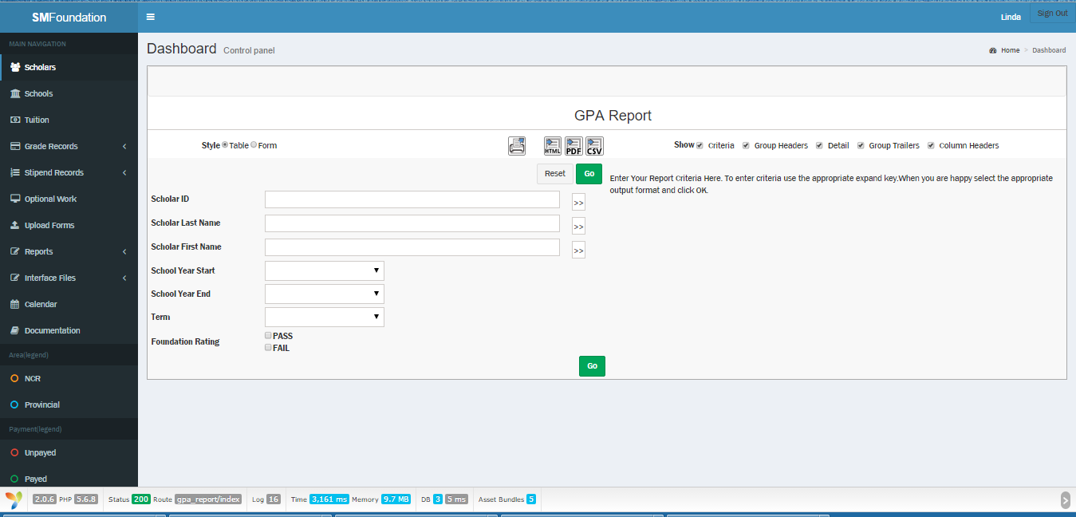GPA
    - 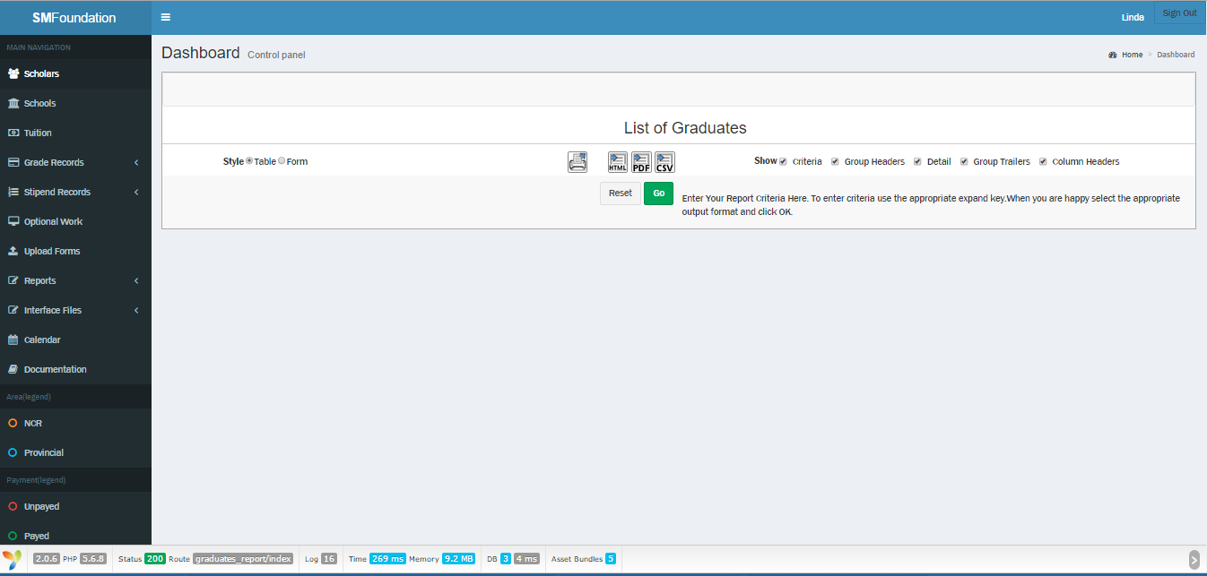Graduates
    - 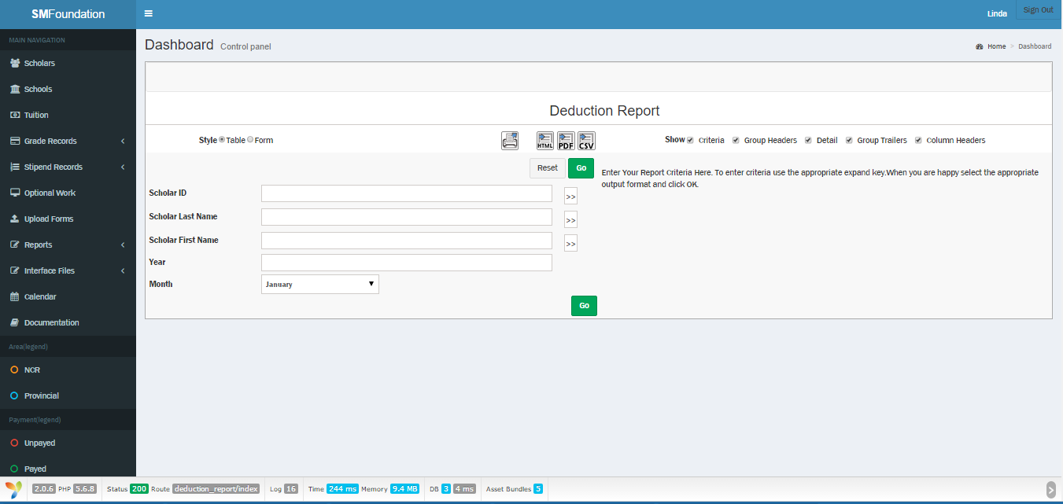Deduction
    - Master list of Scholars

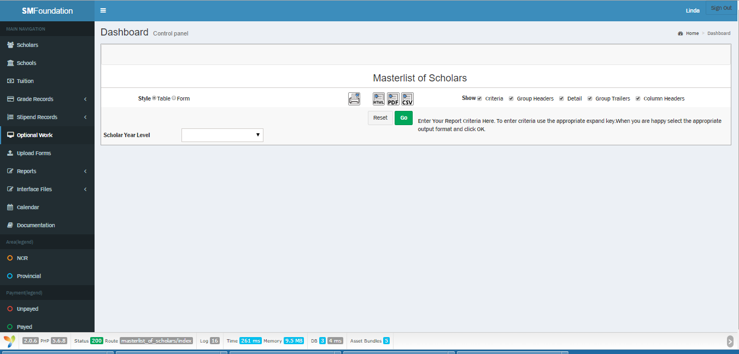

* + - 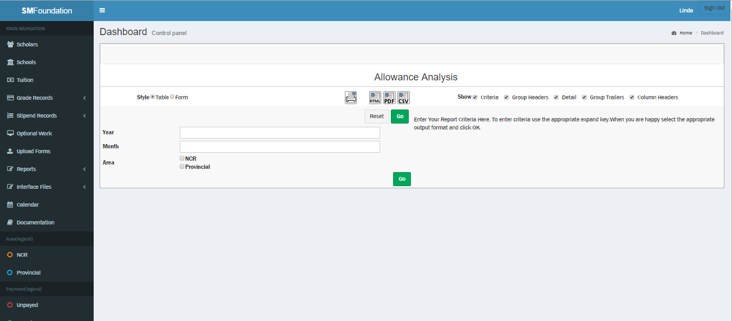Allowance
    - Tuition Fee

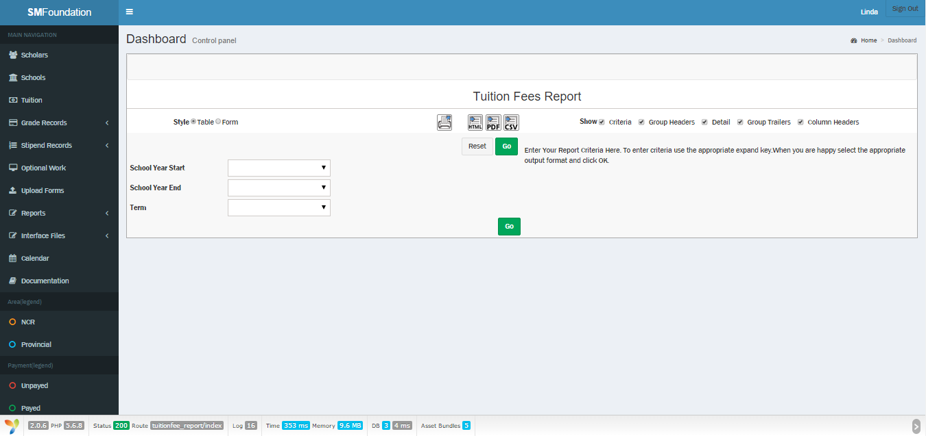

* + EXPORT
* Scholar

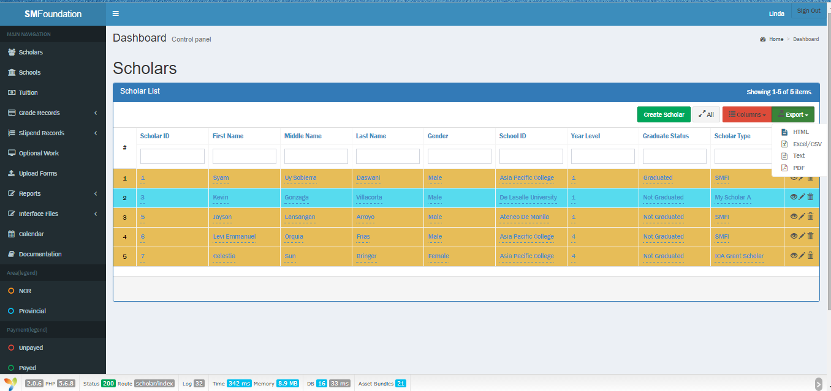

* Schools

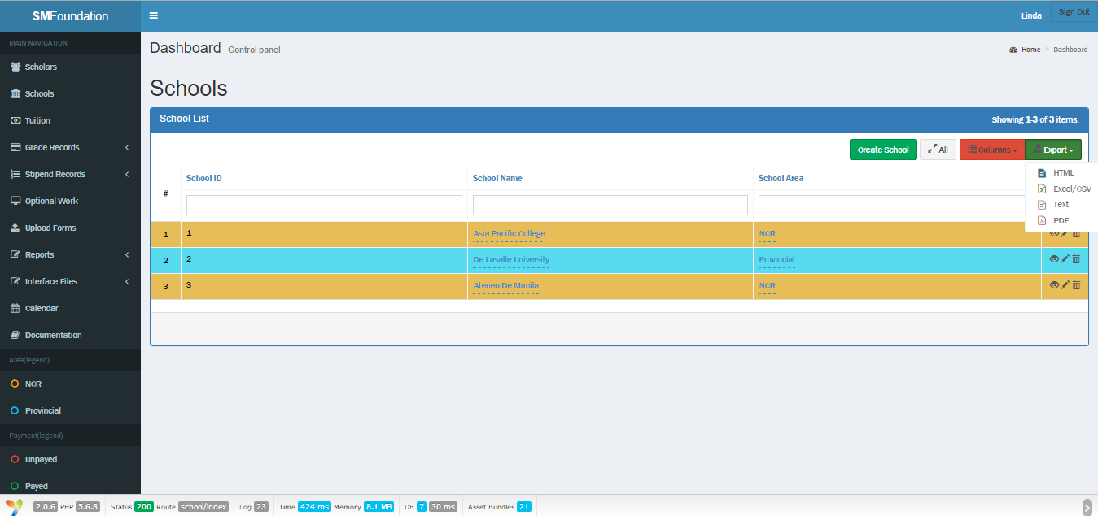

* 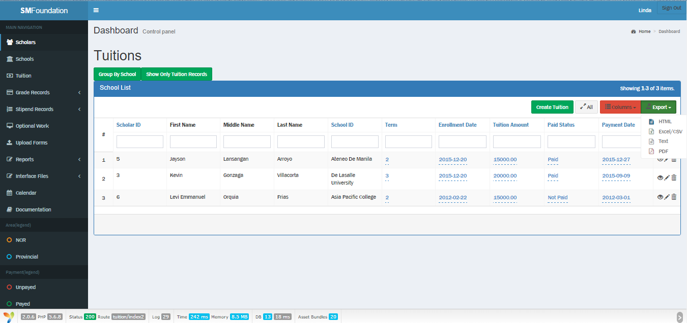Tuition
* 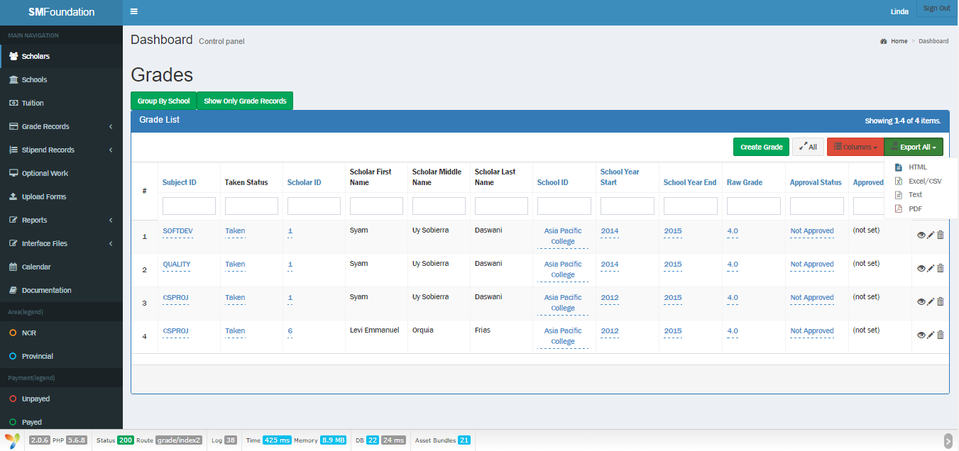Grades
* 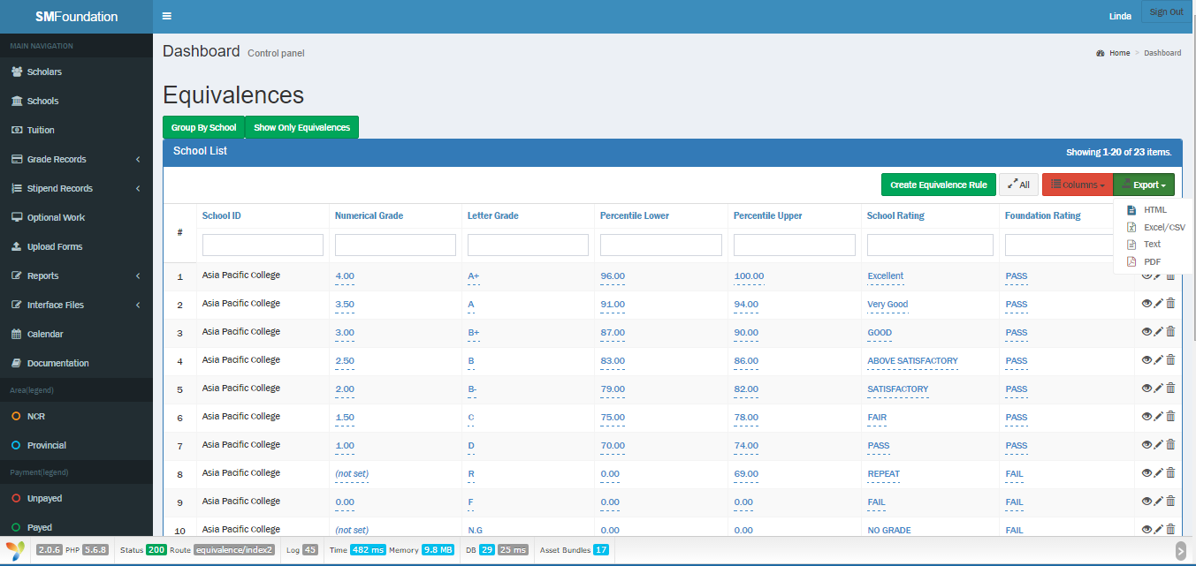Grade equivalence
* 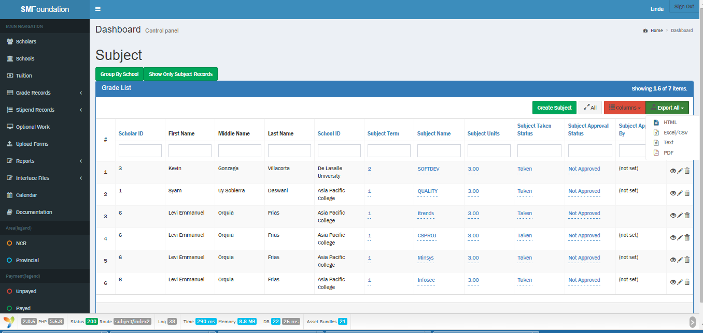Subject
* 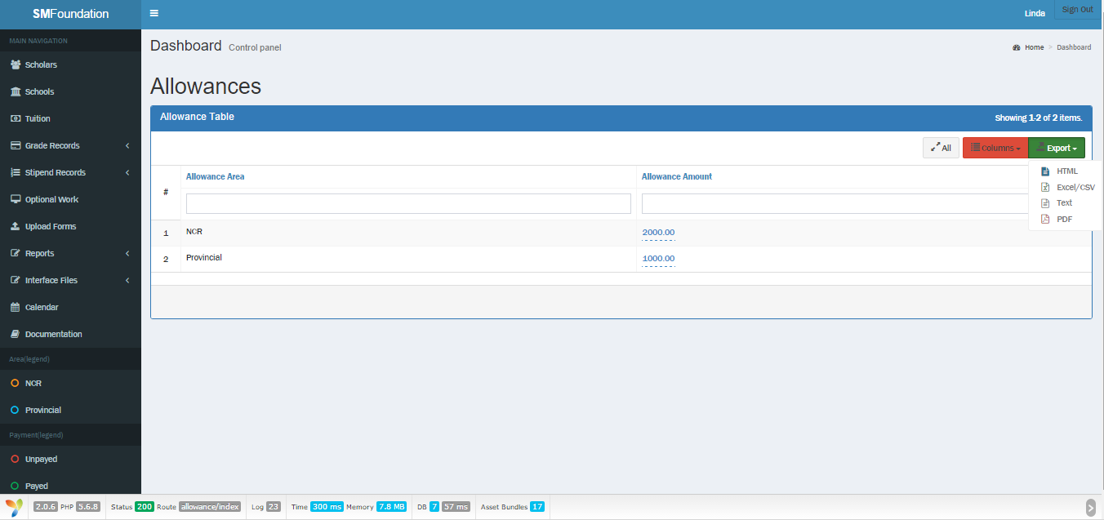Allowance
* 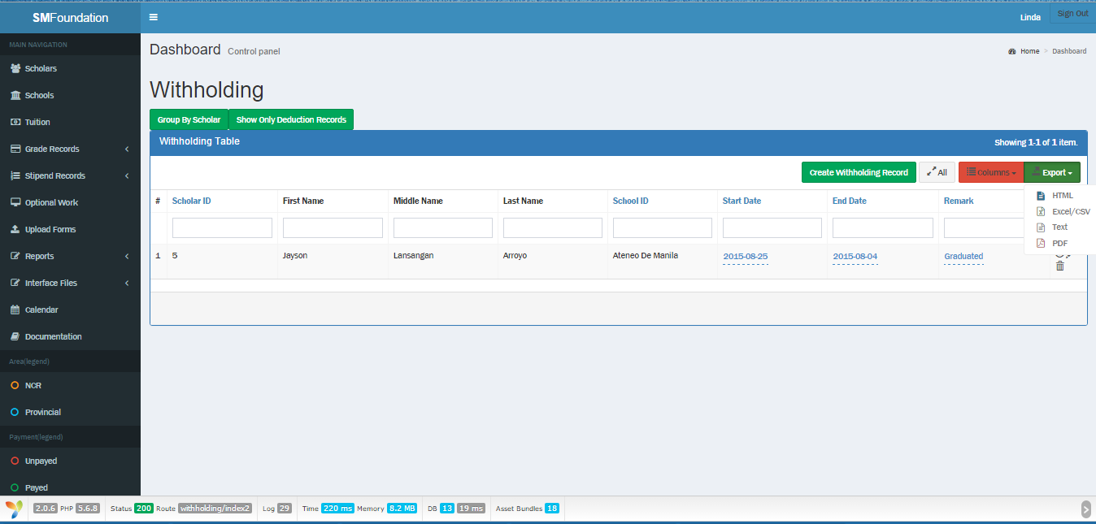Withholding
* 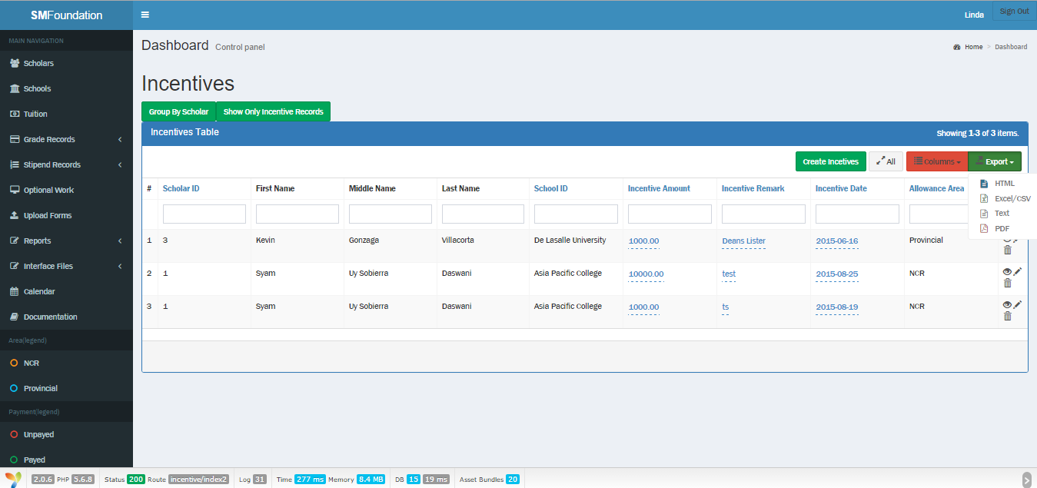Incentives
* 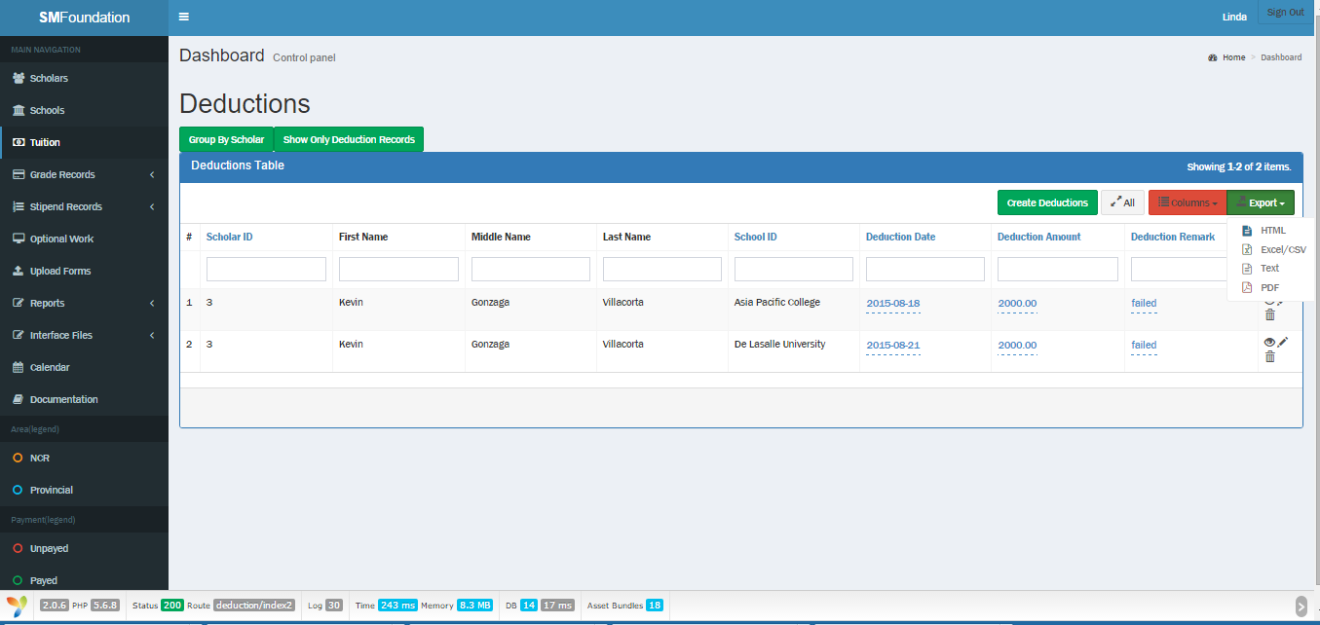Deductions
* 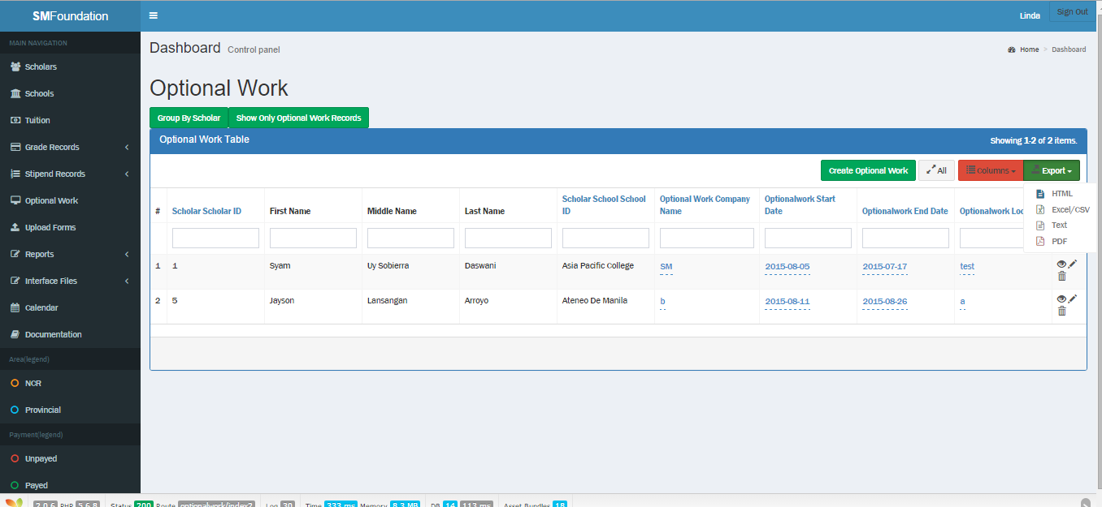Optional work